Unit 5
Enquiry Question 1

What are the processes operating within the hydrological cycle from global to local scale?

Hydrological Cycle
The easiest way to understand the Hydrological Cycle is to view it as a system which has key components. These are key to understanding how movement within the system occurs:
- STORES: these are stocks of water, places where the water is held. For example, the oceans.
- FLUXES: this is the measurement of the rate of flow between the stores.
- PROCESSES: the physical factors which drive the fluxes of water between stores.
This is an example of a closed system. No water is added to the global budget and none is removed.
The system is driven by solar energy and gravitational potential energy.
The water is held in different states (liquid, gas and solid) and stores which vary for both human and physical reasons.
- In the last Ice Age more water was held within the cryosphere in a solid form as snow and ice.
- Recent climate warming is reversing this with major losses of ice in Greenland and Antarctica.
- Humans have built water storage reservoirs (on a smaller scale) which has increased the security of their water supply.
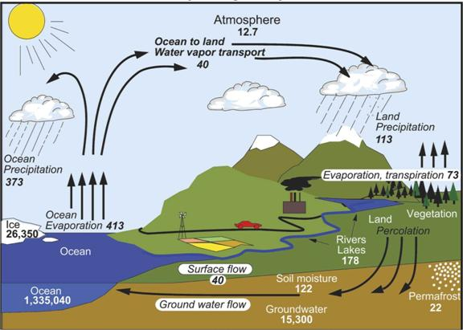

Stores:
The main stores of water are the oceans (96.9%), ice caps and glaciers (1.9%), groundwater (1.1%), and rivers and lakes (0.01%). When it comes to freshwater alone, the store situation is very different: Ice caps and glaciers (68.7%), groundwater (30.1%), and river and lakes (1.2%). With freshwater, a distinction is made between blue water and green water.
Blue Water: Freshwater stored in rivers, streams and lakes – the visible part of the hydrological cycle.
Green Water: Freshwater stored in the soil and vegetation – the invisible part of the hydrological cycle.
Flows and processes:
Flows are the transfers of water from one store to another. They are achieved by processes such as precipitation, evaporation, transpiration, cryospheric exchanges and runoff.
Residence Times:
Water stores have different residence times. In general, the larger the store, the longer the residence time. Some stores are non-renewable; for example fossil water and when the cryosphere melts.
Residence time: The average time a water molecule will spend in a store or reservoir.
Residence times impact on turnover within the water cycle system. Some ancient groundwater, such as that found deep below the Sahara Desert – the result of former pluvial (wetter) periods – is termed fossil water and is not renewable or reachable for human use.
- Major ice sheets store water as ice for very long periods, so the data shows an average.
- Ice core dating has suggested that the residence time of some water in Antarctic ice is over 800,000 years.

The Drainage Basin
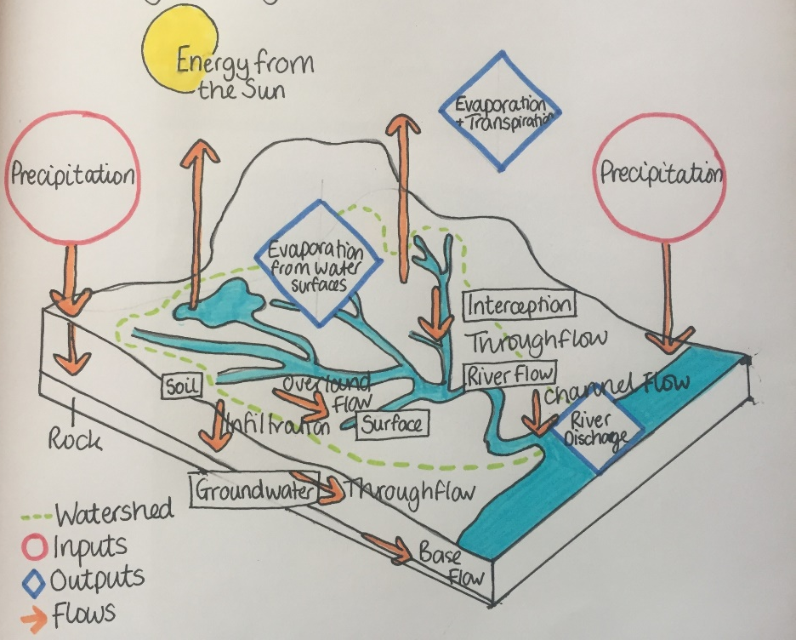
The drainage basin is a subsystem within the hydrological cycle. It is an open system with inputs and outputs. Drainage basins vary enormously in size. E.g. the drainage basin of the Amazon is made up of the drainage basins of tributary rivers. Those tributary basins, in turn, are made up of even smaller basins of streams draining into those tributaries.

Physical factors affecting the drainage basin cycle
Climate | Influences the type of precipitation and the amount of precipitation overall and the amount of evaporation. Climate can also in some locations have an impact on the vegetation type.
Soils | Soils determine the amount of infiltration and throughflow and, indirectly the type of vegetation.
Geology | Impacts the subsurface processes such as percolation and groundwater flow (and, therefore, on aquifers). Indirectly, geology alters soil formation.
Relief | Relief can impact on the amount of precipitation. Slopes can affect the amount of runoff.
Vegetation | The presence or absence of precipitation has a major impact on the amount of infiltration, interception and occurrence of overland flow, as well as transpiration rates.

Human factors affecting the drainage basin cycle
- Deforestation  - Abstraction  - Construction of dams  - Building river defences  - Overpopulation | - Pollution from industry  - Pollution from fertilisers  - Global warming  - Urbanisation
Human activities can affect drainage basins by changing the speed of natural processes, creating new stores and
taking water out of the cycle.
Ground Water Abstraction
In some places water is taken from aquifers at a rate higher than the replacement level. This causes reduced groundwater flow and a lower water tale. Increased industry or
deforestation also increases groundwater storage, increasing the risk of flooding if the water table reaches the surface.
Where?
In China groundwater irrigates 40% of farmland and provides 70% of drinking water in the north-west and
north. Groundwater dropped by a metre per year between 1974-2000.
Dam Construction
Building dams increases surface water stores and evaporation. They reduce downstream river flow and discharge.
Where?
Lake Nasser behind the Aswan Dam in Egypt is estimated to have evaporation losses of 10-16 billion cubic metres every year. This represents a loss of 20-30% of the Egyptian water volume from the River Nile.

Urbanisation
Building creates impermeable surfaces that reduce infiltration and increase surface runoff and throughflow through artificial drains. Often increases river discharge as a result.
Where?
Urbanisation has increased the risk across the UK; there has been increased flooding in Maidenhead (2014), York (2015) and Manchester (2015).
Cloud Seeding
This is the attempt to change the amount or type of precipitation by dispersing substances into the air that serve as cloud condensation nuclei (hygroscopic nuclei). New technology and research claims to have produced reliable results that make cloud seeing a dependable and affordable water-supply practice for many regions, but its effectiveness is still debated.
Where?
China used cloud seeding in Beijing just before the 2008 Olympic Games to create rain to clear the air of pollution.
It is used in the Alpine Meadows ski area in California to improve snow cover, and was used in 2015 in Texas to reduce the impact of drought
Water Budgets
This is the annual balance between inputs (precipitation) and outputs (the channel flow and evaporation).
We can use the following equation to calculate a water budget:
precipitation (P) = streamflow (Q) + evapotranspiration (E) +/- changes in storage (S).
(P=Q+E +/- S)
The water budget shows the times when water naturally enters and leaves the system.
We can therefore see:
- when there is more than enough water (this is called a positive water balance) or
- when there is not enough water (this is called a negative water balance)

This is useful as it shows times where there could be potential drought and challenge to human consumption, agriculture, health etc.
- There is more input than output and so more
water is available. Water runs off into streams,
and groundwater levels are topped up.
- Evapotranspiration increases until it is higher than precipitation so water is drawn up from the soil and starts to get used up
- The point where evapotranspiration is highest and precipitation is lowest due to hot weather conditions. River levels fall, plants use up soil moisture and crops need irrigation.
- Soil water is used up and only specially adapted plants survive.
- Precipitation is higher than evapotranspiration so the amount of soil moisture starts to increase again
- Soil is saturated and cannot hold any more moisture. This is also known as field capacity.

River Regimes
This is the annual variation in discharge or flow of a river. The main factors that affect the regime of the river are:
- Drainage basin area
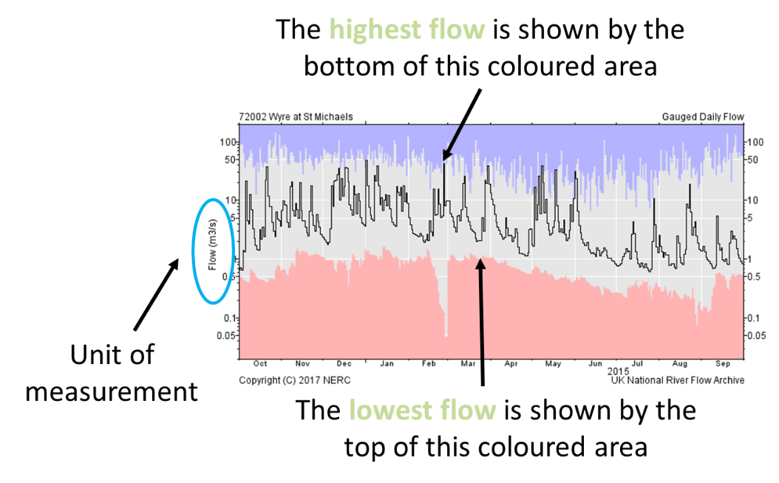
- Maximum altitude
- Variation in altitude
- Geology
- Mean annual
precipitation
- Mean discharge
- Main land use

Comparing River Regimes
Simple regimes – these are where the river experiences a period of seasonally high discharge, followed by low discharge. They are typical of rivers where the inputs depend on glacial meltwater, snowmelt or seasonal storms (e.g. monsoons). Rivers within temperature climates, which rise in mountainous regions where snowmelt occurs, tend to be like this (e.g. the Rhone in France).
Complex regimes – these are where larger rivers cross several different relief and climatic zones, and therefore experience the effects of different seasonal climatic events. This is true of rivers like the Mississippi or Ganges. Human factors can also contribute to their complexity such as damming rivers for energy or irrigation.
A rivers regime reflects differences in precipitation, temperature, evapotranspiration and land use throughout the river’s catchment during the year. Characteristics of the drainage basin itself (shape, geology, soil type, land cover), as well as human intervention, influence a rivers regime. Some of the world’s longest rivers are several thousand kilometres in length, so they may cross several climatic zones and encounter very different land uses and population densities along their course. The longer the river, the more complex the variables tend to be.
The table below shows examples of three complex river regimes.
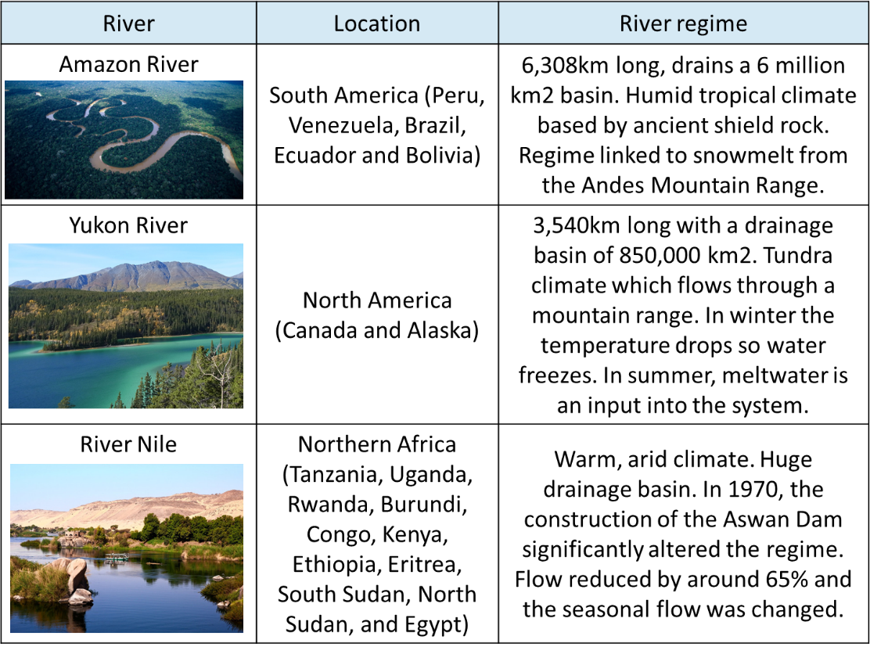

Understanding Storm Hydrographs:
A hydrograph shows how a rivers discharge varies over time. It shows two things: rainfall and discharge. Rises in discharge are related to periods of rainfall or possibly to the melting of snow and ice.
The time lag and the gradient of the rising limb are affected by a number of interacting factors:
- The types of flow carrying the rainwater from where it fell to the river – the more this is by surface runoff, the faster it will reach the river.
- The intensity of rainfall – heavy rain will not sink into the ground; instead it will become overland flow (surface runoff) and quickly reach the river.
- The antecedent conditions – what the ground conditions were like before the particular storm: was the ground already saturated or was it very dry?
- Temperatures affect the form of precipitation – snow can take weeks to melt. If the ground remains frozen, melting snow on the surface can eventually reach the river quickly.
- Geology – hard, impermeable rocks will mean more surface runoff; with porous rocks water will move slowly via through flow and groundwater flow.
- Slopes – steep slopes mean more runoff and a fast direct delivery of water into the river.
- Drainage basin shape – in an elongated drainage basin, the time lag will be less than in a circular one.
- Soil Type – its degree of permeability; how quickly rainwater passes down through the soil.
- Land use- a dense vegetation cover will intercept and delay the rain reaching the ground. However, the tarmac and paved surfaces, building materials and drains of urban areas greatly speed up runoff.
Impact of human activities:
- Urbanisation. This greatly alters the nature of the ground. During heavy rainfall, impermeable surfaces such as roofs, pavements and roads encourage surface runoff and allow little infiltration. Drains also speed up the delivery of rainwater to the river. In short, as a result of urbanisation, the hydrograph will become a quick response one. Urbanisation is also likely to change river landscapes in many ways, but particularly near to any rivers that have a flood risk.

- Deforestation. With trees removed, there will be less interception and more rainfall reaching the ground. Despite increased infiltration, more of the rainfall will reach the river and possibly more quickly than before. The rising limb will become steeper. There is also likely to be soil erosion, particularly on valley sides. The eroded soil will add to the river’s load and possibly lead to some deposition. In short, the slow response hydrograph is typical of a forested area will change and show a steepening of the rising limb.

- Water management (e.g. dams and reservoirs, abstraction). Dams/reservoirs regulate flows downstream by storing water. Abstraction lowers groundwater levels and increases percolation and infiltration when rain falls.

Now test yourself question:
- Why is only such a small percentage of freshwater accessible for human use?
- What is the difference between blue and green water?
- Define Residence time
- What is the cryosphere?
- What are the direct and indirect impacts of geology on the drainage basin cycle?
- Name three human factors which affect the drainage basin cycle
- What is the water budget equation?
- What is a river regime?
- State three variables that could affect the shape of a hydrograph
- Why does urbanisation increase runoff and the risk of flooding?

Possible Exam Questions
- Explain the difference between blue and green water (2)
- Explain why a large proportion of the worlds freshwater is unavailable for human use (4)
- Using examples, outline the differences between a simple and complex river regime (4)
- Explain how the global hydrological system operates as a closed system (6)
- Explain why a drainage basin can be regarded as an open system (6)
- Explain why river regimes are likely to vary between drainage basins (8)
- Explain the factors that would affect the shape of a storm hydrograph (8)
- Using examples, assess the extent to which the hydrological cycle can influence river systems at a local scale (!2)

