Coastal Management Decision Making Exercise
Brief
The East Riding of Yorkshire County Council want to put new sea defences in place along the Holderness Coast. You are going to pitch your ideas to the council. You must come up with a 1-minute presentation deciding which areas to protect along the Holderness Coast and which defence strategies to use. You have a budget of £6 million. You can decide to implement a management strategy at each area, or just one area. What is important is that you justify (give reasons) for your decisions. The best pitch will win the funding. You must weigh-up the cost/benefit analysis of each defence when making your decision. Good luck!
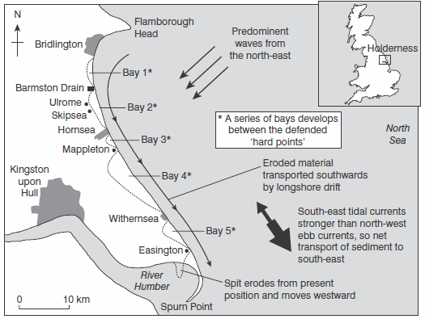
The Sites
C
D
B
A

Fig. 1 Showing the sites that you could put sea defences at: A-Bridlington; B-Ulrome; C-Hornsea; D; Withernsea.

Data
Bridlington  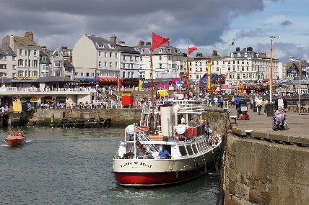 | Population: 33,837  Bridlington is a minor sea fishing port with a working harbour and is well known for its shellfish. It has a mix of small businesses across the manufacturing, retail and service sectors with its prime trade being tourism during the summer months.
Ulrome  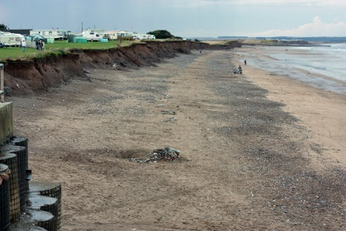 | Population: 206  Ulrome is a small village consisting of mainly retired couples. It has an historic church.
Hornsea  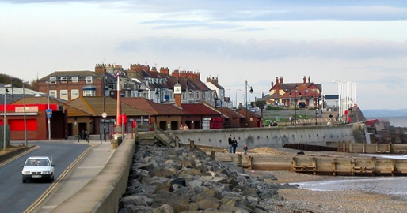 | Population: 8,432  Modern Hornsea still functions as a coastal resort, and has large caravan sites to the north and south.
Withernsea  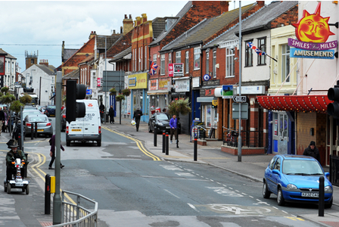 | Population: 6,159  Withernsea, like Hornsea, is popular with holidaymakers. There is a 9-hole golf course and leisure centre complex (with a gym and indoor pool) and a variety of pubs and restaurants are situated around the centre of the town.

Sea Defence Prices
- Sea wall – £5 million.
- Groynes – £500,000 each.
- Rock armour – £2 million.
- Beach nourishment – £2 million per beach.
- Managed retreat - £0, but, local farmers will need to be compensated (£1 million per settlement).

