Answer ALL questions. Write your answers in the spaces provided.

Q1. Study Figure 5 which shows the change in total population, 1981−2011, for some UK regions.
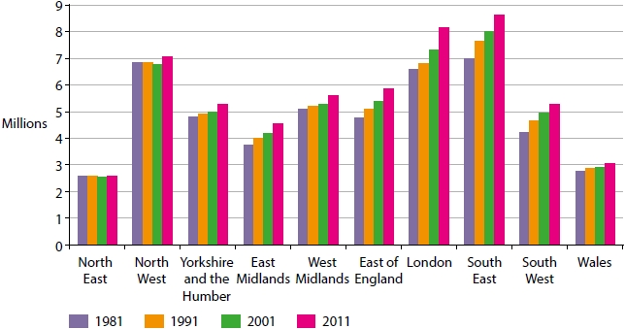
Figure 5
Which of the following regions experienced the largest increase in population between 1981 and 2011?
(1)
A South West
B West Midlands
C London
D Wales

Q2. State two reasons why tertiary employment has increased in the UK.
(2)
1 ..........................................................................................................................................
.............................................................................................................................................
2 ..........................................................................................................................................
.............................................................................................................................................

Q3. The population geography of the UK has been changed by internal migration in the past 50 years.
Explain one reason why some regions of the UK have experienced almost no population growth in the past 50 years.
(2)
.............................................................................................................................................
.............................................................................................................................................
.............................................................................................................................................
.............................................................................................................................................
.............................................................................................................................................
.............................................................................................................................................
Q4. Study Figure 6 which shows the population pyramid for Westminster, an area of central London.
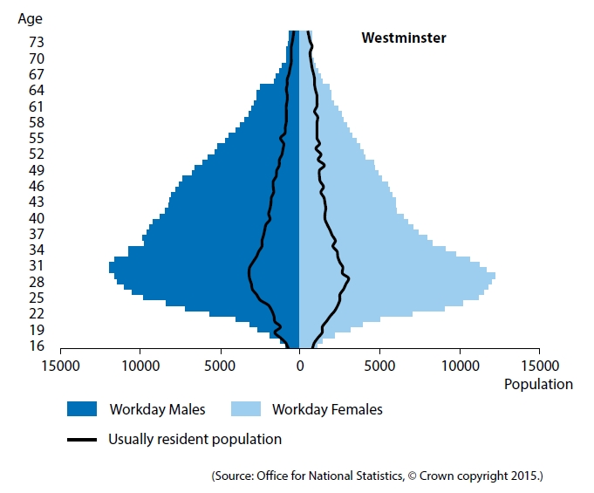
Figure 6
(i) Study Figure 6. Identify the modal class for work day males.
(1)
A 16
B 31
C 43
D 61
(ii) Identify one age group for which the workday female and resident female population is the same.
(1)
.............................................................................................................................................
Q5. Explain one reason why major cities attract large numbers of international migrants.
(2)
.............................................................................................................................................
.............................................................................................................................................
.............................................................................................................................................
.............................................................................................................................................
.............................................................................................................................................
.............................................................................................................................................

Q6. State two characteristics of a Central Business District (CBD).
(2)
.............................................................................................................................................
.............................................................................................................................................
.............................................................................................................................................
.............................................................................................................................................
.............................................................................................................................................
.............................................................................................................................................

Q7. Explain two reasons why the land use of inner cities has changed in the past 20 years.
(4)
1 ..........................................................................................................................................
.............................................................................................................................................
.............................................................................................................................................
.............................................................................................................................................
.............................................................................................................................................
2 ..........................................................................................................................................
.............................................................................................................................................
.............................................................................................................................................
.............................................................................................................................................
.............................................................................................................................................

Q8. Explain the interdependence between cities and their surrounding rural areas.
(4)
.............................................................................................................................................
.............................................................................................................................................
.............................................................................................................................................
.............................................................................................................................................
.............................................................................................................................................
.............................................................................................................................................
.............................................................................................................................................
.............................................................................................................................................
.............................................................................................................................................
.............................................................................................................................................

Q9. Analyse the data in Figure 7. It shows the affordability of houses in urban and rural areas of the UK. Affordability is calculated by comparing average house prices with average incomes.
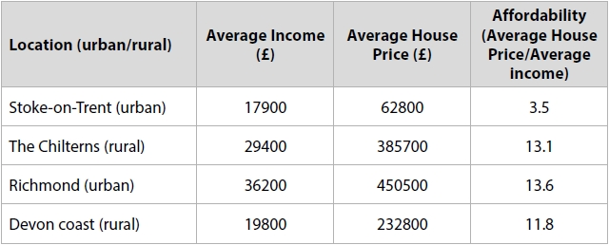
Figure 7
Assess the causes of variations in house price affordability in the UK.
(8)
.............................................................................................................................................
.............................................................................................................................................
.............................................................................................................................................
.............................................................................................................................................
.............................................................................................................................................
.............................................................................................................................................
.............................................................................................................................................
.............................................................................................................................................
.............................................................................................................................................
.............................................................................................................................................
.............................................................................................................................................
.............................................................................................................................................
.............................................................................................................................................
.............................................................................................................................................
.............................................................................................................................................
.............................................................................................................................................
.............................................................................................................................................
.............................................................................................................................................
.............................................................................................................................................
.............................................................................................................................................

Grade Boundaries
90% - 9 55% - 5 25% - 1
80% - 8 45% - 4 24%-0% - U
70% - 7 40% - 3
60% - 6 35% - 2

