**Hazardous Earth (and Challenges Review)**

NAME ____________________________ Total Marks _________/38

PM:

PF:

T:

**Answer ALL questions. Write your answers in the spaces provided.**

1 (a)

(i) Which of the following is an alternative name for a tropical cyclone? (1)

A Hurricane

B Anticyclone

C Monsoon

D Tornado

(ii) The Saffir-Simpson scale is used to categorise tropical cyclones. Which of the following is the most important measurement used when deciding the category of a cyclone? (1)

A The length of time that the cyclone lasts.

B The wind speed in the cyclone.

C The size of the cyclone.

D The height of the storm clouds.

(b) Explain why tropical cyclones lose their power over land. (2)

............................................................................................................................................................................

............................................................................................................................................................................

............................................................................................................................................................................

............................................................................................................................................................................

............................................................................................................................................................................

............................................................................................................................................................................

(c) Analyse the data in Figure 1 which shows the impact of two tropical cyclones.

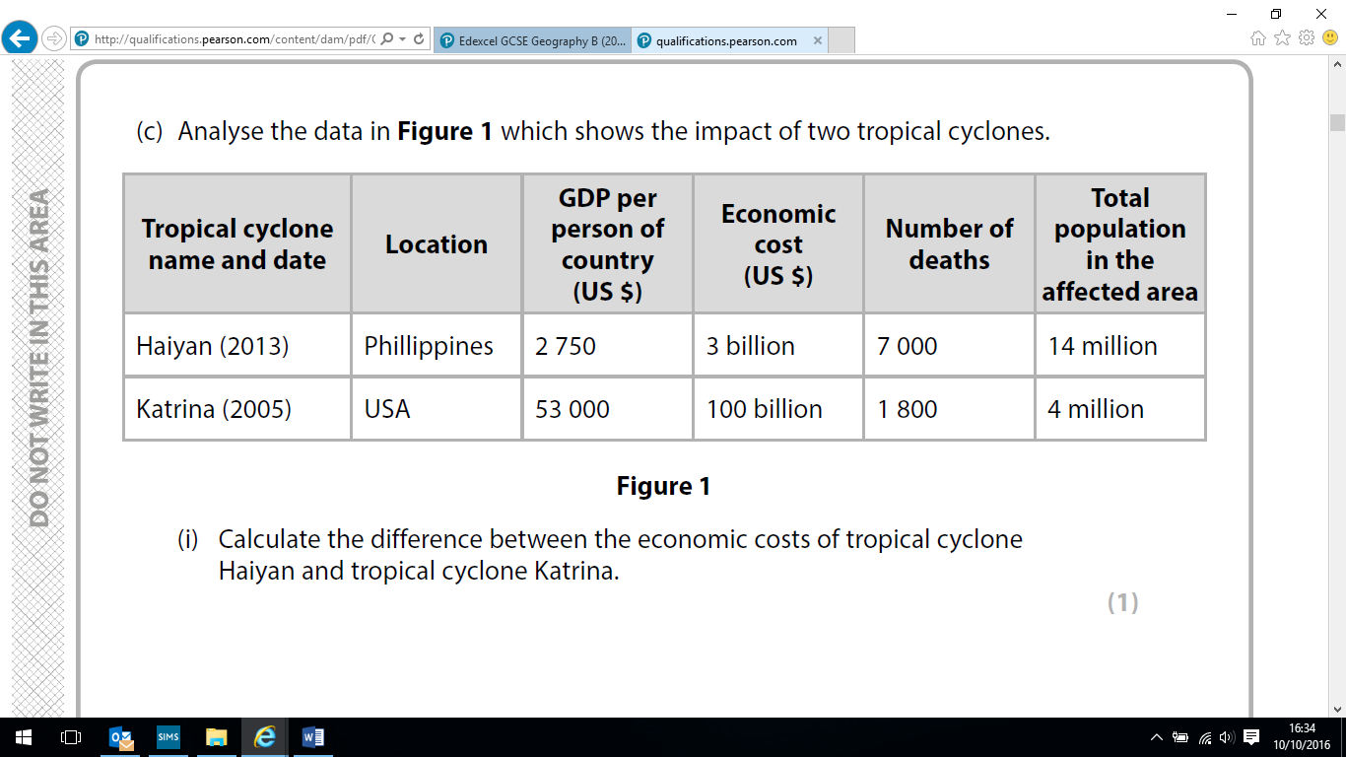

(i) Calculate the difference between the economic costs of tropical cyclone Haiyan and tropical cyclone Katrina. (1)

............................................................................................................................................................................

(ii) For Haiyan, calculate the ratio of the number of deaths to the affected population. (1)

............................................................................................................................................................................

(iii) New Orleans was affected by tropical cyclone Katrina and is located on low-lying coastline.

Explain one reason why low-lying coastlines are vulnerable to tropical cyclones. (2)

............................................................................................................................................................................

............................................................................................................................................................................

............................................................................................................................................................................

............................................................................................................................................................................

............................................................................................................................................................................

(d) Analyse Figure 2, which shows the global distribution of recently active volcanoes.

 Figure 2

(i) Suggest two reasons for the distribution in Figure 2. (4)

1 ............................................................................................................................................................................

............................................................................................................................................................................

............................................................................................................................................................................

............................................................................................................................................................................

2 ............................................................................................................................................................................

............................................................................................................................................................................

............................................................................................................................................................................

............................................................................................................................................................................

(ii) Identify the most appropriate technique to accurately measure volcano type. (1)

A satellite image

B cross section

C seismometer

D pictogram

(iii) Identify two data presentation techniques that would show the contrasting impact of a hazard event on different countries. (2)

A line graph

B population pyramid

C bar graph

D flow line map

E choropleth map

(iv) Other than volcanoes, explain how two tectonic hazards could occur at X in Figure 2. (4)

1 ............................................................................................................................................................................

............................................................................................................................................................................

............................................................................................................................................................................

............................................................................................................................................................................

2 ............................................................................................................................................................................

............................................................................................................................................................................

............................................................................................................................................................................

............................................................................................................................................................................

(e) Explain one way people can predict volcanic eruptions or earthquakes. (3)

............................................................................................................................................................................

............................................................................................................................................................................

............................................................................................................................................................................

............................................................................................................................................................................

............................................................................................................................................................................

(f ) ‘The causes of past climate change and current global warming are different’. Assess this statement. (8)

............................................................................................................................................................................

............................................................................................................................................................................

............................................................................................................................................................................

............................................................................................................................................................................

............................................................................................................................................................................

............................................................................................................................................................................

............................................................................................................................................................................

............................................................................................................................................................................

............................................................................................................................................................................

............................................................................................................................................................................

............................................................................................................................................................................

............................................................................................................................................................................

............................................................................................................................................................................

............................................................................................................................................................................

............................................................................................................................................................................

............................................................................................................................................................................

**Challenges of an Urbanising World Review Questions**

(g) Explain one reason why this growth is concentrated at the rural-urban fringe. (2)

............................................................................................................................................................................................

............................................................................................................................................................................................

............................................................................................................................................................................................

............................................................................................................................................................................................

............................................................................................................................................................................................

............................................................................................................................................................................................

(h) For a named megacity in a developing or emerging country, give two reasons why residential areas have contrasting quality of life. (2)

Named megacity ...........................................................................................................................

............................................................................................................................................................................................

............................................................................................................................................................................................

............................................................................................................................................................................................

............................................................................................................................................................................................

............................................................................................................................................................................................

(i) Megacities in both developing and emerging countries have experienced rapid population growth.

Explain two reasons why rapid population growth leads to problems with water supply. (4)

............................................................................................................................................................................................

............................................................................................................................................................................................

............................................................................................................................................................................................

............................................................................................................................................................................................

............................................................................................................................................................................................

............................................................................................................................................................................................

............................................................................................................................................................................................

............................................................................................................................................................................................

**Grade Boundaries**

**95% - 9 55% - 5 15% - 1**

**85% - 8 45% - 4 14%-0% - U**

**75% - 7 35% - 3**

**65% - 6 25% - 2**