Component 1 – Paper 1 exam for Topics 1, 2, and 3
Topic 1: Hazardous Earth

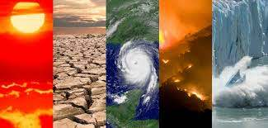
Instructions
1. You will need to use either your Kerboodle login, revision guide, the knowledge organisers that are on the ClassCharts post, or the department’s website: http://www.fulstonmanorgeoggers.weebly.com
2. You are to read carefully the task set on each page and then complete the task in full sentences where expected.
3. If you get stuck, remember the three Bs – Book, Brain, Boss!
Book - Check your resources first (Kerboodle, revision guide, knowledge organiser, website)
Brain – Think it through, you may really already know but are doubting yourself
Boss – email your teacher or message them on ClassCharts
Lesson 1: Global Atmospheric Circulation
Task 1: Read pages 8-13 from your Kerboodle Textbook. If you can’t access this, please read over this page from BBC Bitesize (revision pages 1 and 2).
Now, using what you have learnt, label the lines of latitude onto the diagram below.

Task 2: In your own words, write a short paragraph to explain the Earth’s heat budget (differential heating). Use this video and the diagrams below to help, (with a diagram in your answer to help if needed).

_____________________________________________________________________________________________________________________________________________________________________________________________________________________________________________________________________________________________________________________________________________________________________________________________________________________________________________________________________________________
Task 3: Watch this video and create a diagram showing what happens to air movement and weather during high and low pressure. Start with these 2 arrows.

Challenge: look out of your window now – explain which type of air pressure you think we are experiencing. What evidence have you got to support your point?
__________________________________________________________________________________________________________________________________________

Task 4: Watch this video that explains the global atmospheric circulation model. Use your knowledge to fill in the table below to show the differences between the three atmospheric cells.
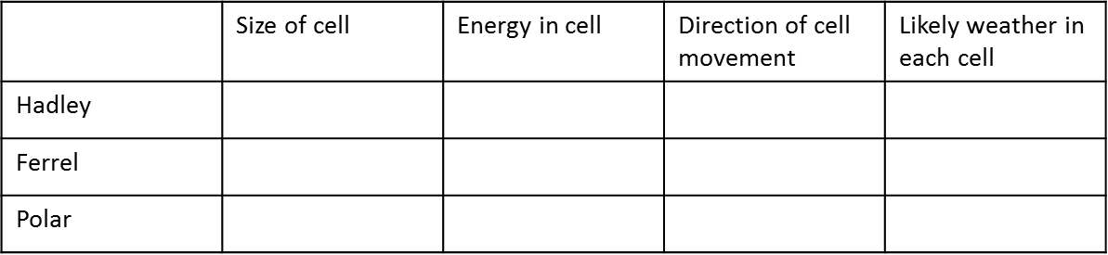
Now, ‘Explain how the atmospheric circulation model distributes heat around the world.’
_____________________________________________________________________________________________________________________________________________________________________________________________________________________________________________________________________________________________________________________________________________________________________________________________________________________________
Task 5: Watch this video explaining the importance of ocean currents to the global heat circulation. Explain how oceans also help to circulate heat around the world.
______________________________________________________________________________________________________________________________________________________________________________________________________________________________________________________________________________________________________________________________________________________________________________________________________________________________
Plenary Challenge: Using your understanding from today’s lesson, annotate (label) the map below to show how tropical deserts and areas of high tropical rainfall have been formed.

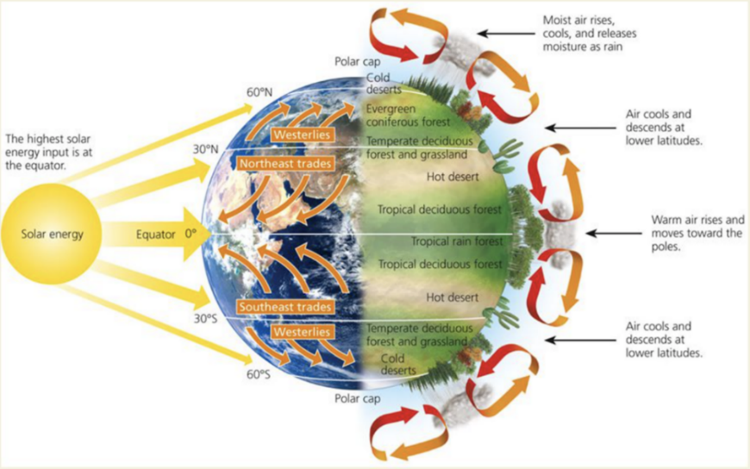
Need help? Look at this diagram to see if it can support your challenge:

Lesson 2: Evidence of Past Climate Change
Task 1: Read pages 16-19 from the Kerboodle Textbook. If you are stuck, you can use BBC Bitesize (Revision pages 1 and 2).
Now, read this passage and then, below, summarise what we mean by natural climate change.
Over the last 800,000 years, there have been natural cycles in the Earth’s climate. There have been ice ages and warmer interglacial periods. After the last ice age 20,000 years ago, average global temperature rose by about 3°C to 8°C, over a period of about 10,000 years.
We can link the rises in temperature over the last 200 years to rises in atmospheric CO2 levels. Rises in temperature are now well above the natural cycle of the last 800,000 years. This all happened WITHOUT human intervention (no additional CO2, pollution etc).

____________________________________________________________________________________________________________________________________________________________________________________________________________________________________________________________________________________
Task 2: Look at the graph below, which shows the link between CO2 concentrations in the atmosphere, global surface temperatures and global sea levels. This has stacked 3 different graphs together to show a pattern.
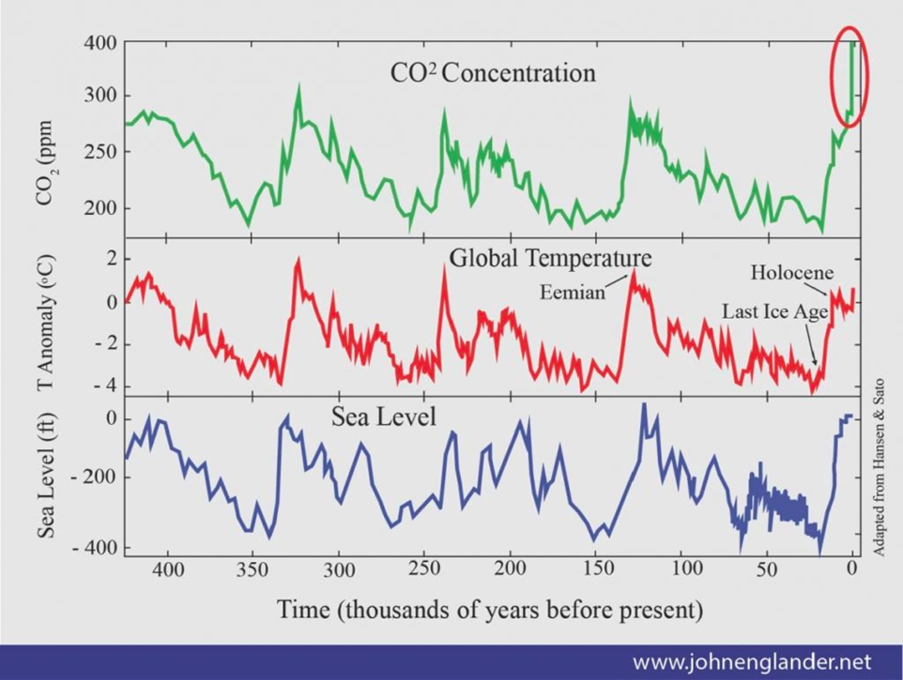
Describe the key trends/patterns you can see over time. Remember to use BETA (beginning, end, trend, anomalies) to help format your answer. Here is your starter sentence:
From the graph it is clear that …
_______________________________________________________________________________________________________________________________________________________________________________________________________________
Task 3: Watch this video about the evidence for natural climate change. Below, fill in the table to help explain what you now know about those 3 pieces of evidence.
Name of evidence | Description | How does it work?
Ice core sampling
Tree rings
Historical records

Which of these three do you think provides us with the most accurate/useful information about past climate? Justify your choice.
_________________________________________________________________________________________________________________________________________________________________________________________________________________________________________________________________________________________________________________________________________________________
Task 4: Watch these videos (1, 2, 3) about natural causes of climate change. Summarise each of the natural causes below using the mindmap that has been started for you:

Plenary challenge: Can you colour code these into long, medium and short term causes?
Lesson 3: Causes and impacts of Current Climate Change
Task 1: Read pages 20-23 from the Kerboodle Textbook. If you are stuck and can’t use this resource, please use this BBC Bitesize page instead (pages 3 and 4).
Now, Spot the difference between natural and enhanced greenhouse effects.
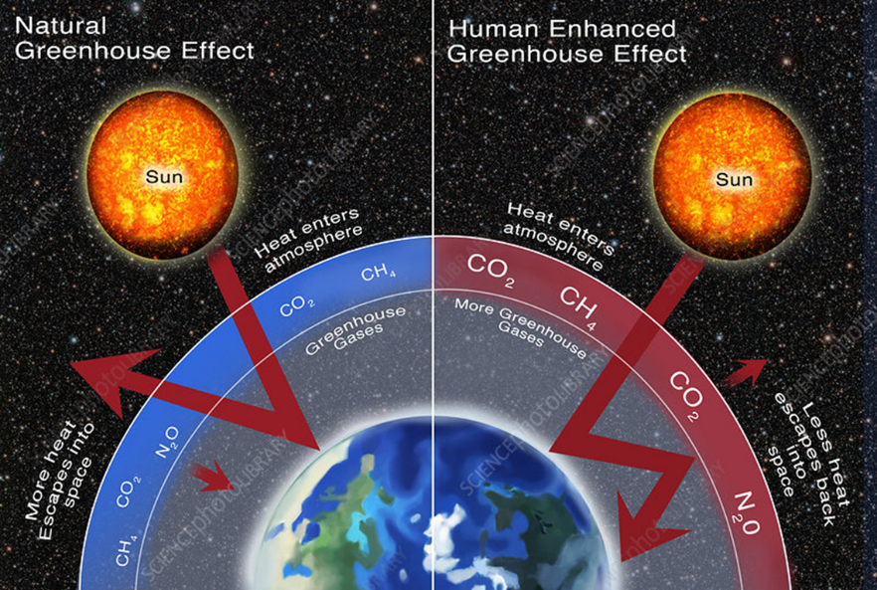
Using the diagram above and your knowledge from the reading, explain how the natural process of the greenhouse effect can be made worse by humans.
____________________________________________________________________________________________________________________________________________________________________________________________________________________________________________________________________________________
Task 2: Using the greenhouse effect diagram and additional information from this website, draw a diagram to show: 1) Where short wave radiation comes from. 2) Where longwave radiation goes. 3) What the greenhouse gases are doing to the longwave radiation. 4) The final impact of this, for Earth.

Task 3: Watch this video. Now, using your knowledge from the video and your reading, fill in the table below to show the major greenhouse gases, their amounts and where they come from.
Greenhouse gas | % of greenhouse gases produced | Sources | Warming power compared to CO2 | % increase since 1850
Carbon dioxide
Methane
Nitrous oxide
Halocarbons
Challenge: Can you suggest which greenhouse gas emission we should be most concerned about?

Task 4: Look at the figure below and using your prior knowledge, explain why people in the developing world produce only a small amount of greenhouse gases. Think about their lifestyles and activities compared to the developed world.
_________________________________________________________________________________________________________________________________________________________________________________________________________________________________________________________________________________________________________________________________________________________
Task 5: Using your knowledge from the reading and the evidence from figure 4 below, describe the predicted changes to global surface temperatures for options a, b and c.
a) ________________________________________________________________________________________________________________________________________________________________________________________________________
b) ________________________________________________________________________________________________________________________________________________________________________________________________________
c) ______________________________________________________________________________________________________________________________________________________

Task 6: Complete the mindmap below, suggesting what the possible impacts of future climate change could be. Challenge – can you point to evidence today that proves that some of these predictions are coming true?
Lesson 4: How do Tropic Cyclones Form?
Task 1: Read pages 24-27 in the Kerboodle textbook. If you cannot access the Kerboodle text, use this BBC Bitesize pages instead (pages 1, 2 and 3 are relevant).
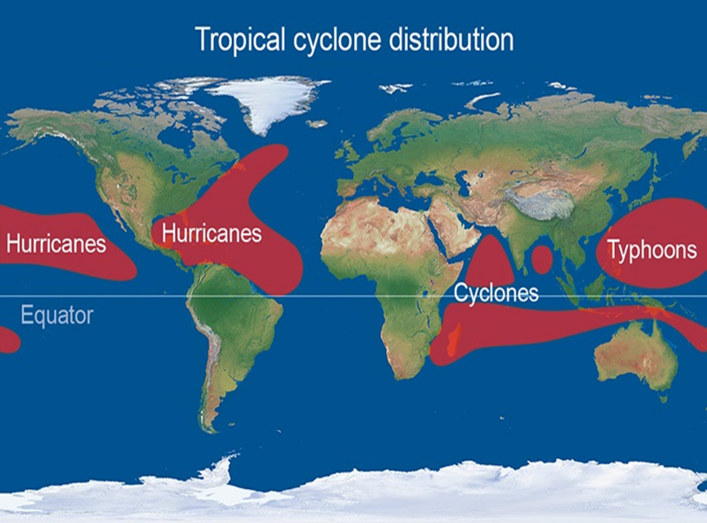
Next, use the map below to describe the distribution of tropical cyclones.
Remember to do the following when describing distribution:
1. Pick out the general trend of location.
2: Give a continent and compass point and name of cyclone (remember from year 8 they can be called hurricanes, typhoons, cyclones and willy willies).
3: Give another continent and compass point and name of cyclone.
____________________________________________________________________________________________________________________________________________________________________________________________________________________________________________________________________________________
Task 2: Watch these two videos (1 and 2) and read back through the formation of a cyclone from either the Kerboodle pages or the BBC Bitesize pages. Create a step by step drawing below for each part of the process. This should help you recall it, as it needs to be in formation order!

Task 3: Watch this video and analyse the diagrams of tropical cyclones provided in the reading in Kerboodle or BBC Bitesize. Then draw your own cyclone with at least 4 key features to it below.

Task 4: What are the different methods for measuring and classifying tropical cyclones? Challenge – can use research to find out what the differences in impacts are between the different Categories of Hurricane using the Saffir-Simpson scale?
_______________________________________________________________________________________________________________________________________________________________________________________________________________
Task 5: Complete the mindmap below to describe the different hazardous impacts of tropical cyclones. Challenge – will climate change make any of these impacts worse?
Lesson 5: Why do tropical cyclones sometimes have different impacts depending on where they occur?
Task 1: Read the two case studies from BBC Bitesize (Typhoon Haiyan and Hurricane Sandy) and watch these videos (1 and 2) to support your understanding.
Using the table below, compare these case study examples.
Name of case study | Location details | Impacts | Responses
Typhoon Haiyan
Hurricane Sandy
Task 2: Now, read pages 30-33 from the Kerboodle textbook. The information across the 4 pages explores the different methods that developing and developed countries can use to prepare for and reduce the impacts of tropical cyclones.
Fill in the table below to describe three methods (at least one developing and one developed – the third is your own choice from across the 4 pages you have read) and evaluate how effective you think each is in protecting a location from the impacts of tropical cyclones.
Method name | How it works | Successes | Challenges | Evaluation (best, worst, in between and why)
Well done! You have completed EQ1 – click on this link to test your knowledge.

