Topic 1: Hazardous Earth
Component 1 – Paper 1 exam for Topics 1, 2, and 3
KEQ 3 – Why do the causes and impacts of tectonic activity and management of tectonic hazards vary with location?
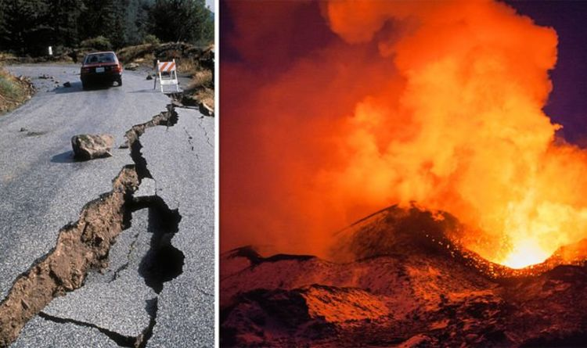

Instructions
1. You will need to use either your Kerboodle login, revision guide, the knowledge organisers that are on the ClassCharts post, or the department’s website: http://www.fulstonmanorgeoggers.weebly.com
2. You are to read carefully the task set on each page and then complete the task in full sentences where expected.
3. If you get stuck, remember the three Bs – Book, Brain, Boss!
Book - Check your resources first (Kerboodle, revision guide, knowledge organiser, website)
Brain – Think it through, you may really already know but are doubting yourself
Boss – email your teacher or message them on ClassCharts
Lesson 6: Structure of the Earth
Task 1: Read pages 34-35 from your Kerboodle Textbook. If you can’t access this, please read over this page from bitesize (revision page 1).
Now, using what you have learnt, label the details of the structure of the earth onto the diagram below.
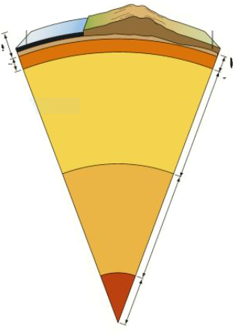

TASK 2: In your own words, explain the difference between continental and oceanic crust (you may use diagrams to help you) – plus this video

_____________________________________________________________________________________________________________________________________________________________________________________________________________________________________________________________________________________________________________________________________________________________________________________________________________________________________________________________________________________________________________________________________________________________________________________________________________________________________________
TASK 3: Read this passage, and then, below, summarise how convection currents work making sure you use diagrams to support your answer. You can also use this video to support you with your diagrams (first part of the video will help you the most)
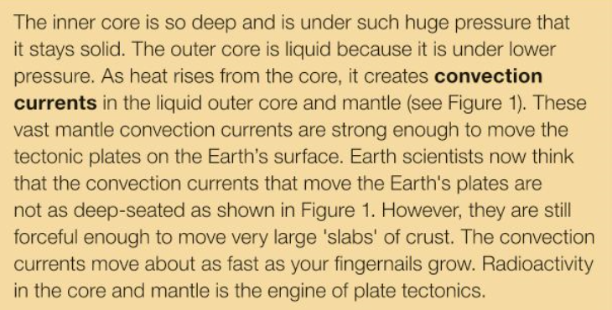
My answer (writing and diagrams)

TASK 4: Answer this exam question;
Other than the mantle, explain the properties of two of earth’s internal layers (4 marks)
___________________________________________________________________________________________________________________________________________________________________________________________________________________________________________________________________________________________________________________________________________________________________________________________________________________________________________________________________________________________________

Lesson 7: Investigating Plate Boundaries
TASK 1: Read pages 38-39 from your Kerboodle Textbook. If you can’t access this, please read over this page from bitesize (revision page 2 and 3).

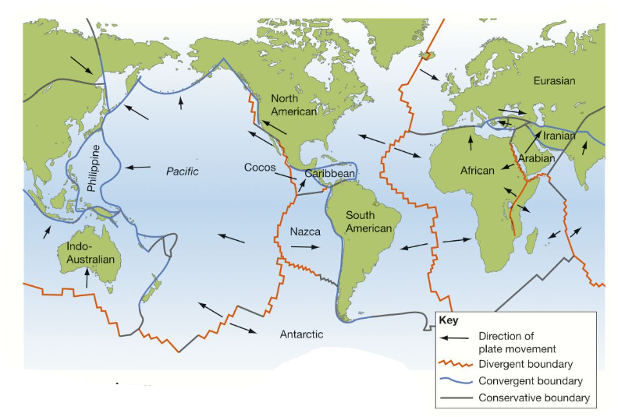
TASK 2: Label the tectonic plates and complete the key:

TASK 3: Complete the sentences
Divergent plate boundaries are formed when two plates move __________.
Convergent plate boundaries are formed when two places move __________.
Conservative (Transform) plate boundaries are formed when two plates _________________________.

TASK 4: Watch the video and use page 40 from the kerboodle book to complete the table below
 | Convergent (Collision) | Convergent (Destructive) | Divergent (Constructive) | Transform (Conservative)
Diagram(s) |  | 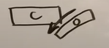
Description | 2 continental plates colliding forms __________ | 1 continental and 1 oceanic forms a __________ zone.  The oceanic subducts beneath the continental because it is (more/less) dense | Occur in the oceans causing ___ _________ ______  Magma rises and forms new igneous rock. This cools when it reaches the _____. It builds up over time forming a ______.
Type of hazard(s) |  | Earthquakes and Volcanoes |  | Earthquakes
Real life example | Himalayas. Formed as the Indian and Eurasian continental plates push into each other

TASK 5: Which type of plate boundary do you think is the most dangerous to live on. Explain why.
___________________________________________________________________________________________________________________________________________________________________________________________________________________________________________________________________________________________________________________________________________________________________________________________________________________________________________________________________________________________________
Plenary Challenge: Why aren’t the Hawaiian Islands found on a plate boundary? Use this video to help you.
___________________________________________________________________________________________________________________________________________________________________________________________________________________________________________________________________________________________________________________________________________________________________________________________________________________________________________________________________________________________________

Lesson 8: Volcanoes and Earthquakes
TASK 1: Watch the video and answer the questions below;
- How many active volcanoes are found across the world?
- Where are most volcanoes located?
- How many of the planet’s volcanoes are contained around the Pacific Ring of Fire?
- What are the main types of volcanoes?
1 –
2 –
3 –
4 –
- When magma breaks through the crust what does it become known as?
- What is a pyroclastic flow?
- What does the VEI stand for?
- When and where was the largest known eruption?
- What are the benefits of volcanic ash?

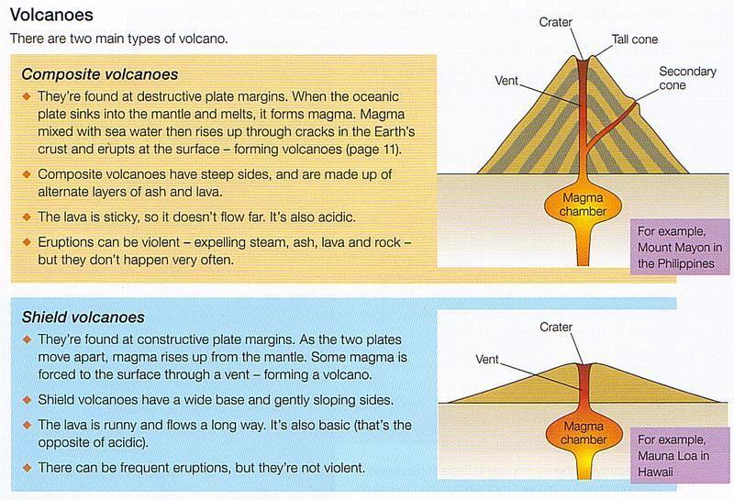
TASK 2: Using the diagrams and information below, complete the table with the correct information
 | Composite/strato-volcano | Shield Volcano
What type of plate boundary? Name me an example
Lava Characteristics

Geographical features (e.g. steep slopes)
Real life example?

TASK 3: Read the information below about Earthquakes
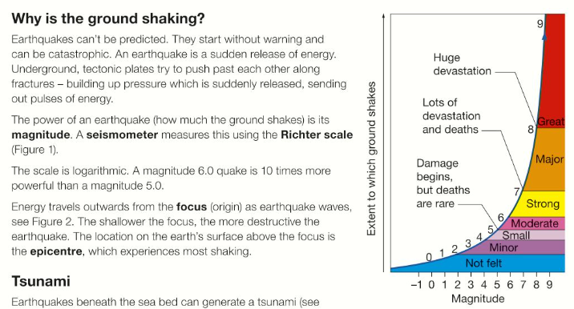

Now, using the table of information below, create a series of images to illustrate the different types of damage at each level of the richter scale.

My illustrations

TASK 4: Watch the following video, and label the diagram below.
earth’s crust / epicentre / focus / fault line / tectonic plate
Challenge: What human influences have an impact on the number of deaths that result from an earthquake?
____________________________________________________________________________________________________________________________________________________________________________________________________________________________________________________________________________________
TASK 5: Watch this TED Ed video about Tsunamis.
Explain the difference between normal waves and Tsunami waves
_________________________________________________________________________________________________________________________________________________________________________________________________________________________________________________________________________________________________________________________________________________________
Plenary: “Gimme 5”!
Give me 5 quick facts you have learnt from this lesson
1 –
2 –
3 –
4 –
5 –
Lesson 9: Developed and Developing World Volcanoes (CASE STUDIES)
Mt Nyiragongo and Mt Sakurajima
TASK 1: Correctly match the number to the label to show the structure of a volcano
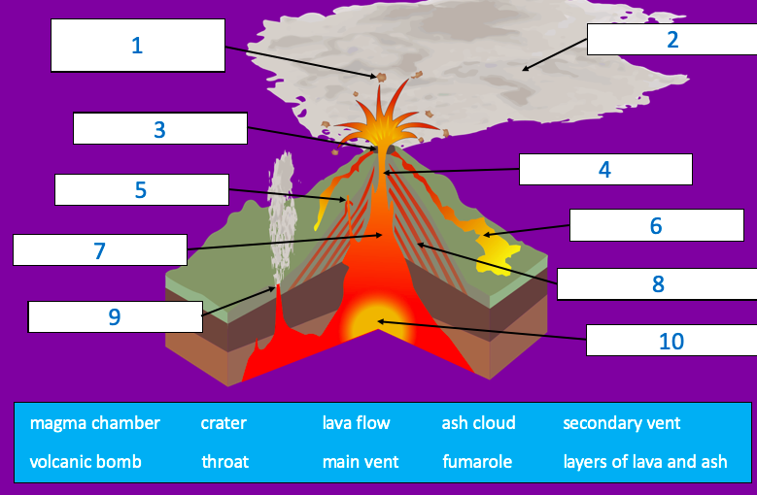
TASK 2: Circle the words above that you think are volcanic HAZARDS (one example shown)
TASK 3: Define the following keyterms:
Primary effects =
__________________________________________________________________________________________________________________________________________
Secondary effects =
__________________________________________________________________________________________________________________________________________

CASE STUDY 1:
DEVELOPED WORLD
Country: Japan
Name: Mount Sakurajima
When: Ongoing
TASK 1: Highlight/circle on the map of the world, the location of this volcanic eruption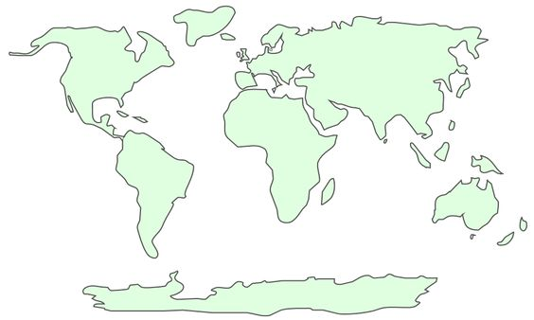

TASK 2: Next to each of the impacts below, place a + or a – to show if it is a positive or a negative impact of the eruption
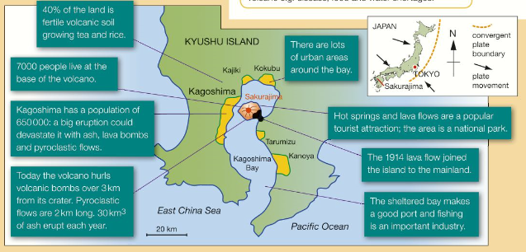
TASK 3: Highlight the methods of prediction in one colour and protection in another colour
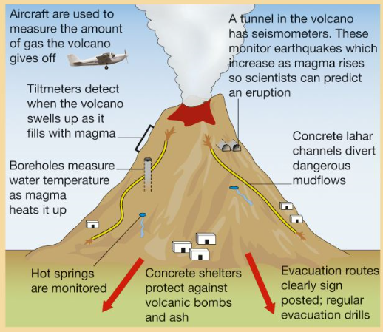

CASE STUDY 2:
DEVELOPING WORLD
Country: Democratic Republic of Congo (DRC)
Name: Mount Nyiragongo
When: January 2002
Death toll: 100

TASK 1: Highlight/circle on the map of the world, the location of this volcanic eruption
TASK 2: Sort the following impacts into social, economic and environmental (you can highlight, code or label)
12 500 homes were destroyed by lava flows and earthquakes
Poisonous gases caused acid rain which affected farmland and cattle – many farmers lost income
400 000 people were evacuated and had to move to overcrowded refugee camps
Due to poverty, most people could not afford to rebuild their homes
Disruption in the mains water supplies caused concern about the spread of disease
100 people died, mostly from poisonous gas and getting trapped in lava
Over 120 000 people were left homeless
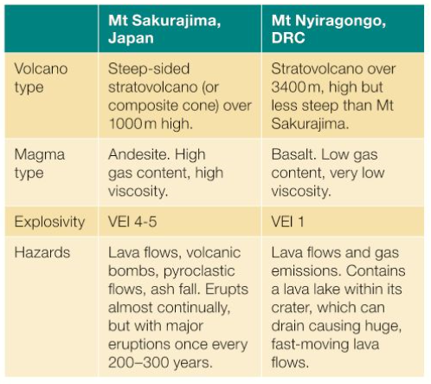
A simple comparison table above
TASK 3: Exam practice
Assess the importance of the primary and secondary impacts of either earthquakes or volcanoes in an emerging or developing country. (8)

Named emerging or developing country ............................................................................................

Examiners comments:

Frequently, candidates laid out paragraphs for each category of impacts, which allowed accurate
AO2 knowledge and understanding to be displayed clearly. Generally, they went on to judge the
severity/significance of the impacts against each other in a summative paragraph, which gave them
access to AO3 credit.

The better Level 3 answers tended to assess the importance of their chosen impacts throughout
the text, so demonstrating a more holistic approach. Successful candidates finalised their answer
with a decision as to which type of impacts were worse and why. Sometimes, they re-iterated what
they considered to be to the most important aspect or why they believed this to be so.
Less frequent was a final paragraph that brought in a new piece of strong evidence that reinforced
the decision very coherently in support of the argument. These candidates tended to achieve 8/8

. 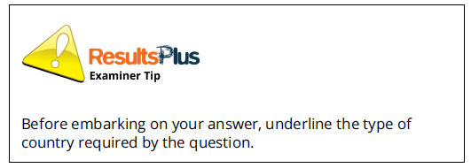
My response:
_______________________________________________________________________________________________________________________________________________________________________________________________________________________________________________________________________________________________________________________________________________________________________________________________________________________________________________________________________________________________________________________________________________________________________________________________________________________________________________________________________________________________________________________________________________________________________________________________________________________________________________________________________________________________________________________________________________________________________________________________________________________________________________________________________________________________________________________________________________________________________________________________________________________________________________________________________________________________________________________________________________________________________________________________________________________________________________________________________________________________________________________________________________________________________________________________________________________________________________________________________________________________________________________________________________________________________________________________________________________________________________________________________________________________________________________________________________________________________________________________________________________________________________________________________________________________________________________________________________________________________________________________________________________________________________________________________________________________________________________________________________________________________________________________________________________________________________________________________________________________________________

