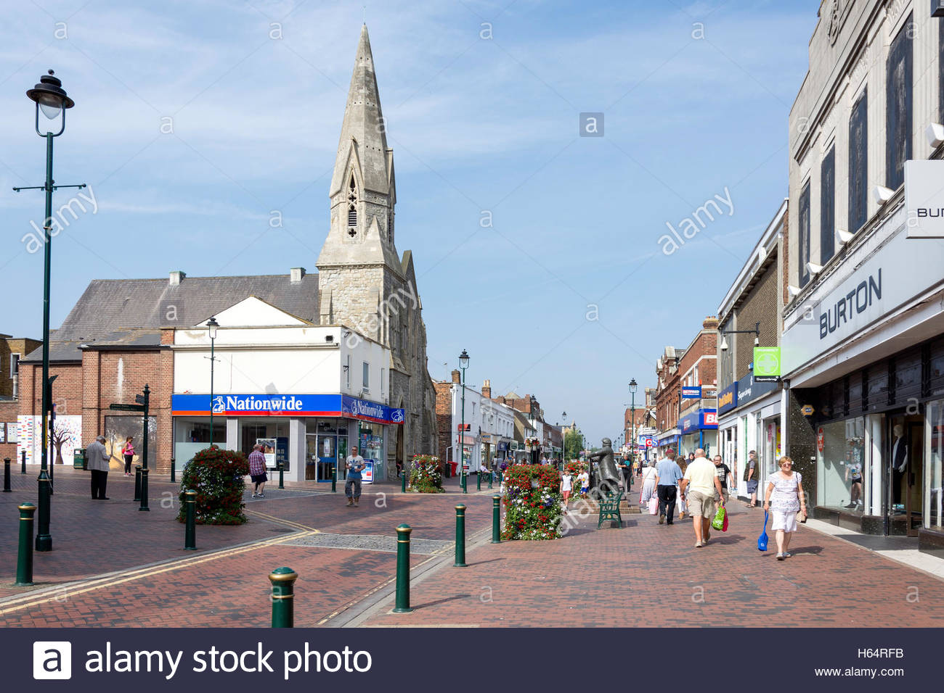**Data Presentation- Showing what we have found!**

Task 3- Annotate these pictures to explain what Sittingbourne is like for young people.

Task 1- Create two bar graphs for the traffic count in each location.

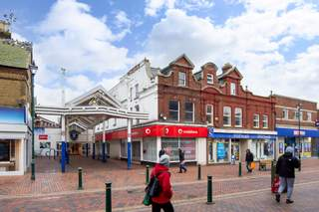

Task 2- Complete the radar graph showing the EQS.

Challenge- show both sites on the same graph!

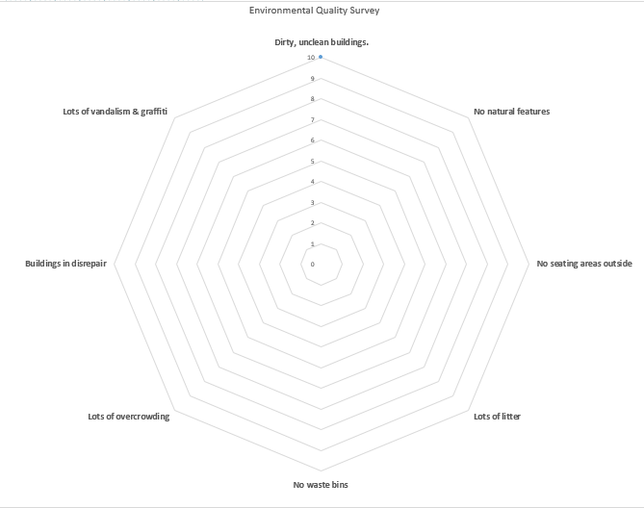

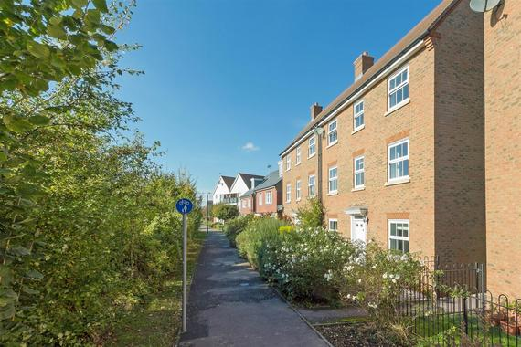

Task 4- Combine your entire primary and secondary data by creating a word cloud to show what key words can be used to describe what Sittingbourne is like for young people. Write the most important/ frequent words larger!

**Teacher assessment.**

FP

PM

PF

|  |  |
| --- | --- |
| **9** | * You have been able to use all of the graph types and explain what they show in detail, identifying clear patterns. * You have been able to apply knowledge to accurately annotate pictures, referencing a range of secondary sources to support answers. * Work is presented extremely well. |
| **8** | * You have been able to use all graph types and explain why they show, identifying some patterns. * You have been able to apply knowledge to accurately annotate pictures, referencing a range of secondary sources to support answers. * Work is presented extremely well. |
| **7** | * You have been able to use most graph types and describe in detail what they show, identifying some patterns. * You have been able to apply knowledge to accurately annotate pictures, referencing secondary sources to support answers. * Work is presented to a high standard. |
| **6** | * You have been able to use most graph types and describe what they show, identifying some patterns. * You have been able to annotate pictures, using some secondary sources to support answers. * Work is presented to a good standard. |
| **5** | * You have been able to use most graphs to show data and identify some patterns. * You have been able to annotate pictures, using your knowledge of the area. * Work is presented to a good standard. |
| **4** | * You have been able to use most graphs to show data. * You have been able to label pictures. * Work may lack some labels and other key aspects of graphs. |
| **3** | * You have been able to use most graphs to show data. * You have been able to label pictures. * Work lacks good presentation. |
| **1-2** | * With structure or support use some basic graphs to display and collect data * Begin to use some secondary sources |

**Task:**

1. Improve the presentation of your work by ensuring all labels are complete, all lines are done with a pencil and a ruler and keys are used.
2. Explain what your different graphs/ presentation techniques show. Include data in your answer.
3. Add secondary research on crime data, IMD data, census data or views on Sittingbourne to your annotations.
4. Complete your graphs and the challenge task of annotating the Spirit of Sittingbourne picture.

**Challenge- Picture annotation about the future!**

