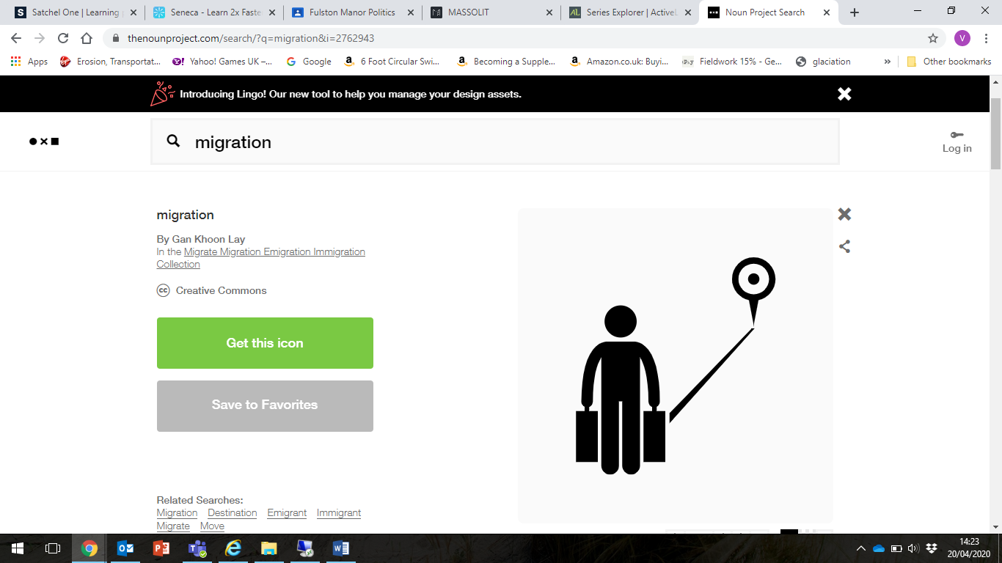

**Paragraph 3 – Final reason to stay in Siberia or move to Moscow.**

**__________________________________________________________________________________________________________________________________________________________________________________________________________________________________________________________________________________________________________________________________________________________________________________**

**Paragraph 3 – Second reason to stay in Siberia or move to Moscow.**

**__________________________________________________________________________________________________________________________________________________________________________________________________________________________________________________________________________________________________________________________________________________________________________________**

**Paragraph 2 – First reason to stay in Siberia or move to Moscow.**

**__________________________________________________________________________________________________________________________________________________________________________________________________________________________________________________________________________________________________________________________________________________________________________________**

**Paragraph 1 – Reason for writing**

**__________________________________________________________________________________________________________________________________________________________________________________________________________________________________________________________________________________________________________________________________________________________________________________**

**Dear _____________________________**

**Date**

**Address 1**

**Address 2**

**Moscow or Bust Persuasive Letter**