GCSE
Topic 2: Development Dynamics Workbook 1

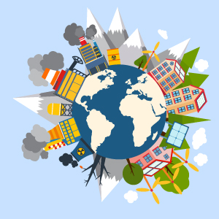

Lesson outline:
Lesson | Title
Lesson 1: | Measuring Development
Lesson 2: | Development and Population
Lesson 3: | Why does inequality exist?
Lesson 4: | What is holding Malawi back?
Lesson 5: | Theories of Development
Lesson 6: | Development in a globalised world
Lesson 7: | Mid Topic Assessment

Extension tasks:
Lesson | Task
EXT1: | Complete ‘Development Indicator’ worksheet. You must also suggest whether it would be high/low in certain countries and the positive and negative of using each indicator.
EXT2: | Comparing Development Indicators between countries – pdf from Edexcel
EXT3: | Seneca Tasks – review what you know so far about Development using the link provided.
EXT4: | For a named developing country, assess how far patterns of trade have affected its economic development. (12 marks) Complete Model Answer activity worksheet.
EXT5: | Exam Qs 2.4-2.6 – as can be found in the Kerboodle textbook (blue questions on the odd pages)

Lesson 1: Measuring Development First, read pages 52-53 in the Kerboodle text or read this BBC Bitesize page.
Learning Objective: To define the term development and explain the different ways it can be measured
Starter:
- What do you think the average income of a UK citizen is?
_______________________________________________________________________________________________
- Do you think somebody who earns that much money is classed as ‘rich’?
_______________________________________________________________________________________________
_______________________________________________________________________________________________
Task 1: What is development?
https://www.youtube.com/watch?v=pRmjoF5nv6s&safe=active
Level of development – means a country’s wealth (measured by its GDP), and its social and political progress (e.g. its education, health care or democratic process in which everyone can vote freely).
Outline the three different types of development
Social Development
Economic Development
Environmental Development
Stretch: How could you measure each of the above definitions?
__________________________________________________________________________________________________________________________________________________________________________________________________________________________________________________________________________________________

Task 2: Using the following words, complete the gap fill on the various development indicators you can use to assess a countries level of development
capita | female | data | gap
excluded | biased | population | hidden
combines | divides | differ | benefit
absent | Western | every | elections
money | accurate | pregnancy | unequal
wealth | living | outside

Gross Domestic Product (GDP) per _________ takes the money made within a country in a year and _________ it by the number of people in the country.

Advantages:
- Data is available for ___________ country with an economic structure.
Disadvantages:
- It uses an average amount of money per person and so hides any _________ between rich and poor people. (India, for example, has about 60 billionaires – but millions of people below the poverty line.)
- Does not include important activities that do not involve _________ (e.g. subsistence farming).

Gross National Income (GNI) per capita is used as a measure of national _________.

Advantages:
- GNI is similar to GDP but considers wealth created _________ the country by its companies, and such things as debt.
Disadvantages:
- Doesn’t take into account the way in which cost of _________ varies between countries (e.g. 1 dollar buys more in India than in the USA)

Human Development Index (HDI) considers several aspects of development, e.g. income, education and life expectancy, and COMBINES them into one scale.

Advantages:
- Covers a wider range of factors – social and economic – and so is considered a more _________ measurement of overall development.
Disadvantages:
- Some _________ is not available for all countries
- Does not consider the natural environment or inequalities within countries.

Happy Planet Index (HPI) considers how efficient individual countries are at using their resources to _________ their people, without causing long-term damage to the environment.

Advantages:
- It considers sustainability and how well supported a __________ is by its government
Disadvantages:
- Economic aspect is _________,
- Measure needs to be used with other indicators to give a better view of development.

Gender Inequality Index considers FEMALE participation in the workforce and decision-making processes, the level of education of women, and their degree of control over _________ .

Advantages:
- It specifically targets a group that are often _________ during the development of a country
Disadvantages:
- The role of women varies considerably between societies, and therefore some of the indicators used may be _________, which will skew the results.

Political Freedom measures political rights and civil liberties, including the freedom of _________, the number of people voting or the number of people with the right to vote, freedom of speech and individual rights.

Advantages:
- Uses 7 different measures, combined with 25 key questions judged by experts.
- The data has been assembled since 1973, so trends over time can be identified.
Disadvantage:
- Bias towards the ‘_________ ‘ ideas of freedom.

Corruption Perception Index looks at perceived corruption in governments and their departments. If development is to take place, a government should be working for the people.

Advantages:
- It covers 183 countries
- Combines different sources of information.
Disadvantages:
- Perceptions are used because corruption is _________ and difficult to measure

The Gini Coefficient measures the extent to which the distribution of income is _________ within a country and changes over time. It allows comparisons to be made between countries.

Advantages:
- The Gini Coefficient can be used no matter how large or small a population is.
Disadvantages:
- It loses information about national and personal incomes. Countries may have identical Gini coefficients, but _________ greatly in wealth.

Task 3: What is the Human Development Index?
Based on four variables:
- Life Expectancy (health)
- Level of Education (literacy rate)
- Level of Education (average years of schooling)
- GDP per capita (wealth- GDP)
This covers quality of life. Each variable is given a score from 1.0 (the best) to 0.0 (the poorest).
Q. Outline the differences between countries ranked highest and lowest on the Human Development Index (3 marks)
___________________________________________________________________________________________________________________________________________________________________________________________________________________________________________________________________________________________________________________________________________________________________________________________________________________________________________________________________________________________________________________________

Q. Describe the distribution of countries measured through the HDI (3 marks)
_____________________________________________________________________________________________________________________________________________________________________________________________________________________________________________________________________________________________________________________________________________________________________________________________________________________________________________

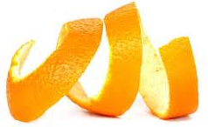
Task 4: Exam Question Practice:
Explain three indicators that show a country’s level of development (6 marks)
One way we can measure development is by measuring the life expectancy of the population. The longer the life expectancy the more developed the country, as their quality of life is likely to be higher. This does not give us a full picture however as it does not tell us what their life is like or whether they are educated.
Another way we can measure development is by measuring the _________________ of the population. _____________________________________________________________________________________________________________________________________________________________________________________________________________________________________________________________________________________________
A composite indicator you can use to measure development of a country is the Human Development Index. ____________________________________________________________________________________________________________________________________________________________________________________________________________________________________________________________________________________________________________________________________________________________________________________________
/6
Extension 1: ‘Development Indicator’ Worksheet
TASK: Match up the correct development indicators with the correct definitions
1 The number of people who are born per 1,000 people
Life expectancy
Birth rate
Death rate
% of adult literacy
2 The wealth of a country. This is measured by total value of goods and services produced by a country and divided by its population (Gross National Product)
GNP (per capita)
Infant Mortality Rate
Population growth
Population per doctor
% of children who go to school
% in agriculture
Calories consumed per person per day
% population infected by HIV/AIDS
12 This indicator effects the economy, health services and family / community ties.
9 The number of doctors divided by the number of people in the population.
8 The average age people of a given population are likely to live to.
3 Whether family trends show lots of children per family or few/none children per family.
11 The % of people who work in farming and therefore primary industry.
10 The number of calories eaten each day and divided between the population.
7 The number of people who die per 1,000 people
6 The number of children who die under the age of two.
5 The % of people who can read and write within a population
4 The number of children who regularly attend school
Task 2: Now rethink each definition and write the words HIGH or LOW next to each development indicator which would show us whether a country is MEDC e.g. you would write HIGH next to GNP as this would be HIGH for a rich country.
Lesson 2: Development and population Read pages 54-55 in the Kerboodle textbook or use this BBC Bitesize.
Learning Objective: To explain the ways in which the demographic of a country can change as it develops and the impacts of this.
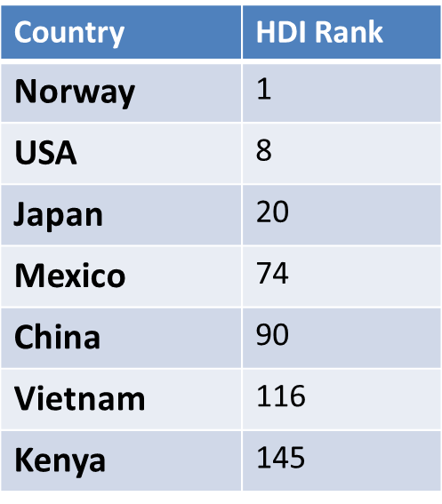
Starter:
- Explain how the level of development may vary between these countries.
_______________________________________________________________________________________________________________________________________________________________________________________________________________________________________________________________
- Suggest reasons for this
____________________________________________________________________________________________________________________________________________________________________________________________________________

Task 1: Demographic Data:
Define demographic data: ______________________________________________________________________________________________________________________________________________________________________________________________
- Developed: country with very high human development
- Emerging: country with high/medium human development
- Developing: A country with low human development – poor country
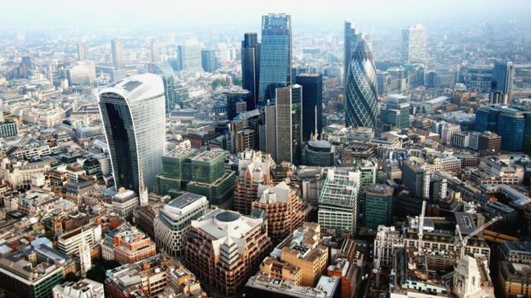
Identify 2 countries which you would identify as:
Developed:
1)
2)
Developing:
1)
2)
Emerging:
1)
2)

Task 2: Features of a population pyramid
A population pyramid: is a bar graph which shows the age and gender structure of a country, city or other area.
Label what each part of a population pyramid shows:
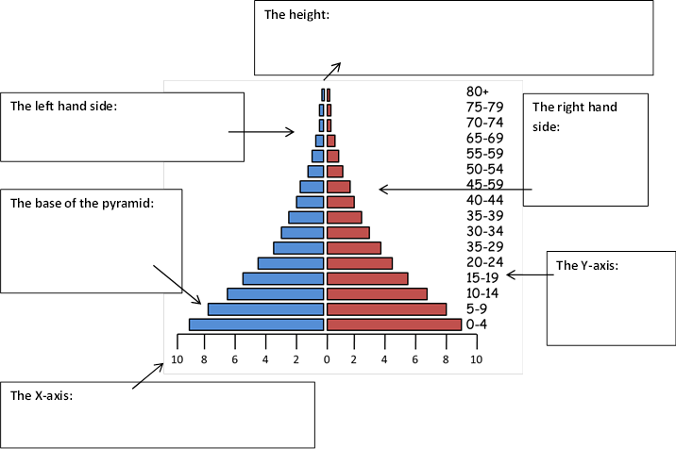

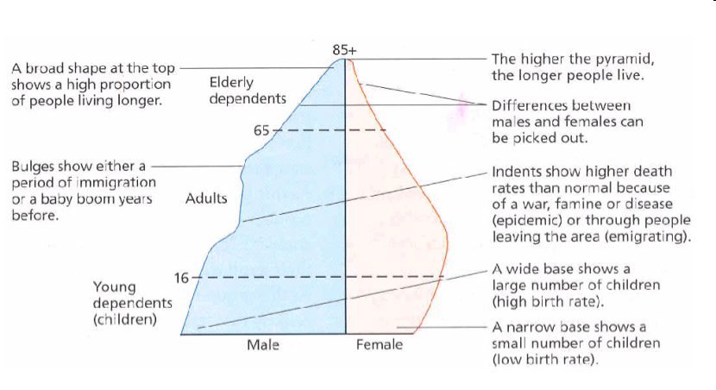
The diagram below explains how the shape of a population pyramid can explain the demographics of a population
Task 3: Describe the population structure of each country using the data below
- Annotate the pyramids – shape of the pyramids, highest/ lowest age groups, life expectancy/death rate, fertility rate
- Describe the key differences between the pyramids. Consider the following points:
- The shape of the pyramids
- The highest/ lowest age groups
- Explain the reasons for the different shapes
- Birth rate is low in UK because.....
- Life expectancy in Niger is low because............... And so on..................
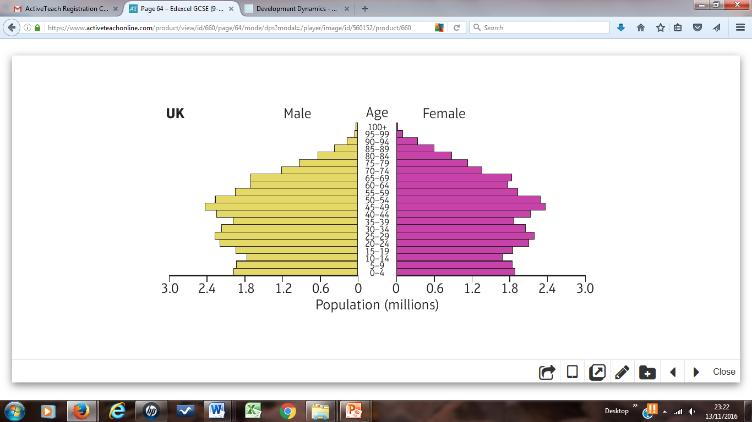
Task 4: Demographic Transition Model: DTM

Complete the table below with a description of what is occurring in each stage of the Demographic Transition Model (DTM)
Stage | 1 | 2 | 3 | 4 | 5
Birth Rate
Death Rate
Natural Increase
Reasons for changes in birth rate
Reasons for changes in death rate
Examples | e.g. | e.g. | e.g. | e.g. | e.g.
Task 5: Women’s health and education - Malawi
- In most developing countries (e.g. Malawi) women are poorer than men
- In Malawi, many women work on the land
- 25% of mothers are undernourished (among the world’s worst maternal and infant mortality rates)
- Skilled workers only attend 20% of births
- Babies of unhealthy mothers are more likely to die in their first five years
- Primary education is free in Malawi, but there are few state secondary schools – most charge fees (which subsistence families cannot afford)
- Few girls attend secondary school beyond the age of 13 – in rural areas they marry at 13/14

Q. Explain why economic and social development can only take place if a country improves lives for women and children. (4)
Reason 1:
_____________________________________________________________________________________________________________________________________________________________________________________________________________________________________________________________________________________________
Reason 2:
_____________________________________________________________________________________________________________________________________________________________________________________________________________________________________________________________________________________________
/4
Extension 2: Link to comparing development indicators from Edexcel
Lesson 3: Why does inequality exist? Read pages 56-57 in the Kerboodle text or use this page from Study Rocket
Learning Objective: To explain the causes and potential consequences of global inequality.
Starter: Annotate around the image
- Explain what this image is trying to represent and suggest some reasons for this ‘development gap’

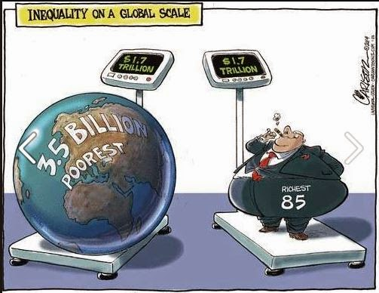

Task 1: The Brandt Report
In 1980, German Chancellor William Brandt published a report which highlighted global differences between rich and poor, the poverty of many developing countries, and the vast wealth of a few developed nations
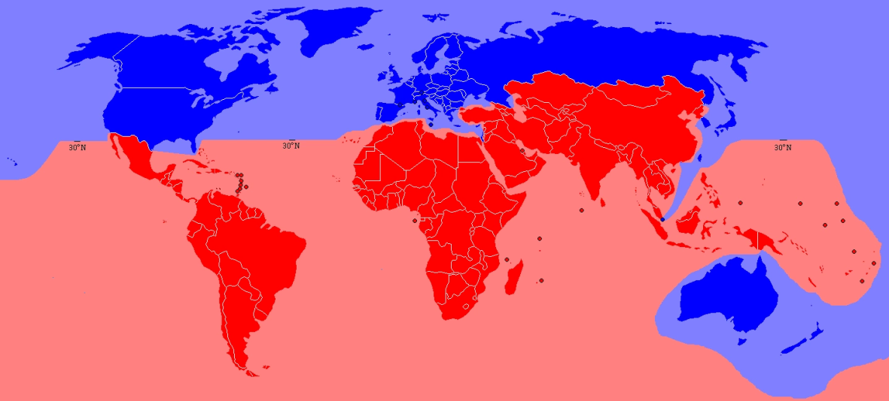

Global North
Global South

Task 2: Global shares of wealth
The World Bank ranks countries by total GDP, from 1 (the USA, with US$17 trillion), to 230 (Tuvalu US$39 million).

The top quintile (the richest 5th – owns 83% of the worlds wealth
The bottom two quintiles (the poorest 40%) – owns just 3% of the worlds wealth

Q. Describe the distribution of wealth between the countries of the world. (3 marks)
T ______________________________________________________________________________________________________________________________________________________________________________________________
E
______________________________________________________________________________________________________________________________________________________________________________________________
E
______________________________________________________________________________________________________________________________________________________________________________________________
/3

Task 3: Causes of inequality: https://www.youtube.com/watch?v=9-4V3HR696k
Create a mind map of reasons you think can create inequality in the world.

Causes of Inequality

Choose 3 of your causes and complete the table below.
Factor causing inequality | How does it cause inequality? | Possible consequences of this inequality | Importance in causing inequality: 1-5 (5 is strongest factor)

Task 4: Exam Question Practice:
Using Figure 3, Explain how much of the world has changed since 1980. (6 marks)
There have been many changes within the world’s global economies, due to rapid development, migration and expansion of TNCs. As a result many emerging economies are becoming wealthier.
Rapid development has resulted in….
_______________________________________________________________________________________________________________________________________________________________________________________________________________________________________________________________
this can be seen in….
______________________________________________________________________________________________________________________________________________________________________________________________
Due to the relocation of manufacturing overseas this has resulted in…
____________________________________________________________________________________________________________________________________________________________________________________________________________________________________________________________________________________________________________________________________________________________________________________________
An example of this can be seen in…
______________________________________________________________________________________________________________________________________________________________________________________________
Industrialisation has also seen an increase in trade within…
_____________________________________________________________________________________________________________________________________________________________________________________________________________________________________________________________________________________________
/6

Extension 3: Seneca Review of learning so far.

Lesson 4: What is holding Malawi back? Read pages 58-61 in the Kerboodle textbook or use this page.
Learning Objective: To explain the physical, economic, political and environmental barriers to Malawi’s development.
Starter: Why might corruption create a barrier to development within a country?
______________________________________________________________________________________________________________________________________________________________________________________________
Q. Describe the location of Malawi (3 marks)
__________________________________________________________________________________________________________________________________________________________________________________________________________________________________________________________________________________________________________________________________________________________________
Hint: Think of Continents, Countries and Oceans,

Task 1: What does Malawi’s population pyramid show about the level of development in Malawi?
Think about birth rate, death rate, life expectancy. EXT: what can we learn about literacy rates, access to clean water, the number if doctors per 1000 people?
____________________________________________________________________________________________________________________________________________________________________________________________________________________________________________________________________________________________________________________________________________________________________________________________________________________________________________________________________________________________________
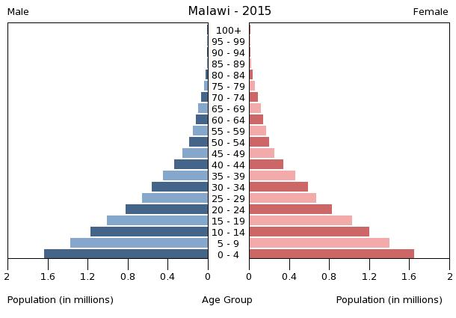
Life expectancy | 60.66 years
Infant mortality rate (per 1000 live births) | 46.2
Literacy rate | 65.8%
Birth rate | 41.5
Death rate | 8.4
Task 2: Outline the physical and environmental barriers that affect Malawi’s development
Landlocked: | Rural Isolation:
Living with Climate Change: | Increased Pollution:

Task 3: Outline the economic and political barriers that affect Malawi’s development
Terms of Trade: | Cash Crops:
Colonisation: | Global Trade and international relations:

Task 4: Exam Question Practice:
/8
Explain two physical factors that can prevent development progress in a country (4 marks)
Climate can have a considerable impact on development, for example, the variable ____________ in Malawi that has seen crop __________ fall. When rains have arrived they have been intense and led to __________ and destroyed thousands of homes. If a country is _______________ it has no port to import and export __________, affecting its development. To reach Malawi, goods have to be transported on a slow ______km railway which increases the_______ of imports and could put off companies from locating their ______________ in Malawi.
flooding | cost | landlocked | yields
goods | rainfall | 800 | business

Explain two economic factors that can prevent development progress in a country (4 marks)
Using the following keywords complete your answer to the question above, words in the same colour box refer to the same factor.
terms of trade | Primary products | Manufactured goods | Raw materials
Colonisation | Plantations | Commodities | Tariffs
______________________________________________________________________________________________________________________________________________________________________________________________________________________________________________________________________________________________________________________________________________________________________________________________________________________________________________________________________________________________________________________________________________________________________________________________________________________________________________________________________________________________________________________________________________________________________________________________________________________________________________________________________________________________________________________________________________________________________________________
Extension 4: Model Answer Worksheet
For a named developing country, assess how far patterns of trade have affected its economic development. (12 marks)
The first paragraph has been done for you – it has gained you 4 marks already (3 for content 1 for SPAG):
Malawi’s patterns of trade have had a significant impact on its economic development. For example, the value of Malawi’s exports each year is less than its imports, so every year it earns less than it spends. One reason why Malawi has such poor terms of trade is that they export largely raw materials, also known as primary products. It has then sold these on to developed countries, and in return bought manufactured goods that it does not make itself.
As a result, its terms of trade are stacked against it.

Can you now finish the response? You need to focus on other factors that have affected Malawi’s economic development. Use your notes from the lesson today to support 2 more paragraphs arguing the country is held back by more than just its terms of trade.
__________________________________________________________________________________________________________________________________________________________________________________________________________________________________________________________________________________________________________________________________________________________________________________________________________________________________________________________________________________________________________________________________________________________________________________________________________________________________________________________________________________________________________________________________________________________________________________________________________________________________________________________________________________________________________________________________________________________________________________________________________________________________________________________________
Lesson 5: Theories of Development Read pages 62-63 in the Kerboodle Textbook or use this page from Study Rocket.
Learning Objective: To explain two different theories regarding how countries develop over time.
Starter: Match-up the correct definition to the correct key word.

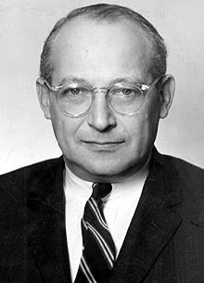
Task 1: The Rostow Model: https://www.youtube.com/watch?v=jgFecxrGceQ
- Walt Rostow was an American economist who worked in the US government after WWII.
- In 1960, he published his theory- called the Rostow model- based on how countries like the UK and USA developed.
- He believed that countries should pass through 5 stages of development.
- Given enough time, all countries would become fully developed.

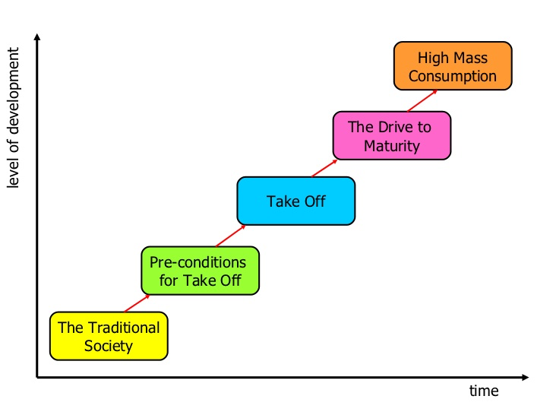
Complete the following model with the 5 stages of the Rostow Model
Stage 1: | _______________________________________________________________________________________________________________________________________________________________________________________________________________________________________________________________________________________________________________________________________________________________________________________
Stage 2: | _______________________________________________________________________________________________________________________________________________________________________________________________________________________________________________________________________________________________________________________________________________________________________________________
Stage 3: | _______________________________________________________________________________________________________________________________________________________________________________________________________________________________________________________________________________________________________________________________________________________________________________________
Stage 4: | _______________________________________________________________________________________________________________________________________________________________________________________________________________________________________________________________________________________________________________________________________________________________________________________
Stage 5: | _______________________________________________________________________________________________________________________________________________________________________________________________________________________________________________________________________________________________________________________________________________________________________________________
Copy the correct information next to the correct stage on your diagram

Criticisms of Rostow’s Model:
- Rostow’s theory is outdated (1960) and too simplistic
- Not all countries follow the same path of development. Some skip stages.
- Not all countries start off the same or have the same pop, res and climate.
- The model is based on the experiences of Europe (Eurocentric.)
- Overlooks other paths to development e.g. promoting tourism, attracting FDI.
- The model is ‘one-way’ but some countries do not achieve this because their economies stall or even fall backwards due to debt and corruption.

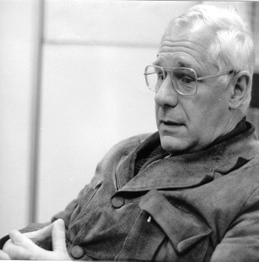
Task 2: Frank’s Dependency Theory:
- In the 1970’s, the dependency theory was developed by Andre Frank- in opposition to Rostow’s ideas.
- Frank believed that development was about two types of countries- core and periphery.
- The core is developed, powerful countries like North America, Europe.
- Periphery is other areas which produce raw materials.

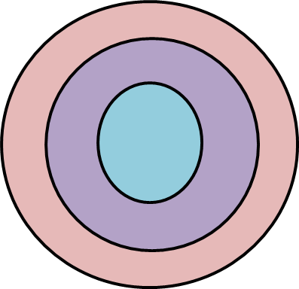
Complete the following diagram to represent the theory

Goods

Resources

Core
Periphery

He disagreed with Rostow because…
- Historical trade made countries poor.
- He believed poorer countries aren’t simpler versions of wealthier countries, but are weaker members of the global economy.
Criticisms of Frank’s Deepndency Theory:
- It is argued that colonialism did have positive benefits because it provided LIC’s with a basic infrastructure (e.g. transport and communications).
- Never colonised LICs such as Ethiopia and Afghanistan experience severe problems today because they lack the infrastructure provided by the colonial powers.
- Some countries such as Bangladesh have grown poorer despite increased aid from the West over two decades.
- Campaigns such as ‘Make Poverty History’ and ‘Fair Trade’ are examples of positive links between developing and developed countries.

Task 3: Exam Question Practice:
Explain how Rostow’s model can be used to explain the development of a country (4 marks)
Rostow's model explains the development of a country by identifying the different stages it progresses through, beginning with traditional society where most people work in an agricultural "subsistence economy". As agriculture shifts to manufacturing, the country is getting ready for "take off" - a period when investment and technology create new opportunities. The "Drive to maturity" is a period of growth and production of consumer goods before the economy reaches "High Mass Consumption" which is a period when consumers enjoy a wide range of goods and society is wealthy.
Point

Explain
Extension 5: Exam Qs 2.4-2.6 in the Kerboodle Textbook

Lesson 6: Development in a globalised world Read pages 64-65 in Kerboodle Textbook or pages 1-4 on BBCBitesize
Learning Objective: To explain the reasons why some countries benefit from globalisation more than others.
Starter: Think....100 years ago:
- If you wanted to travel to Australia, how would you get there and how long would it take?
_______________________________________________________________________________________________
- If you wanted to buy a coat, where would you buy it from and where would it be made?
_______________________________________________________________________________________________
- If we went to another area of the world, would we see similar or different shops/fashions? Why?
_______________________________________________________________________________________________
Task 1: Define the term ‘globalisation’
_______________________________________________________________________________________________
_______________________________________________________________________________________________
_______________________________________________________________________________________________
Q. Describe how GDP has changed in different regions of the world from 1980-2010 (3 marks)
Trend:
________________________________________________________________________________________________________________________________________________
Evidence:
______________________________________________________________________________________________________________________________________________________________________________________________
Evidence:
_____________________________________________________________________________________________________________________________________________________________________________________________________________________________________________________________________________________________

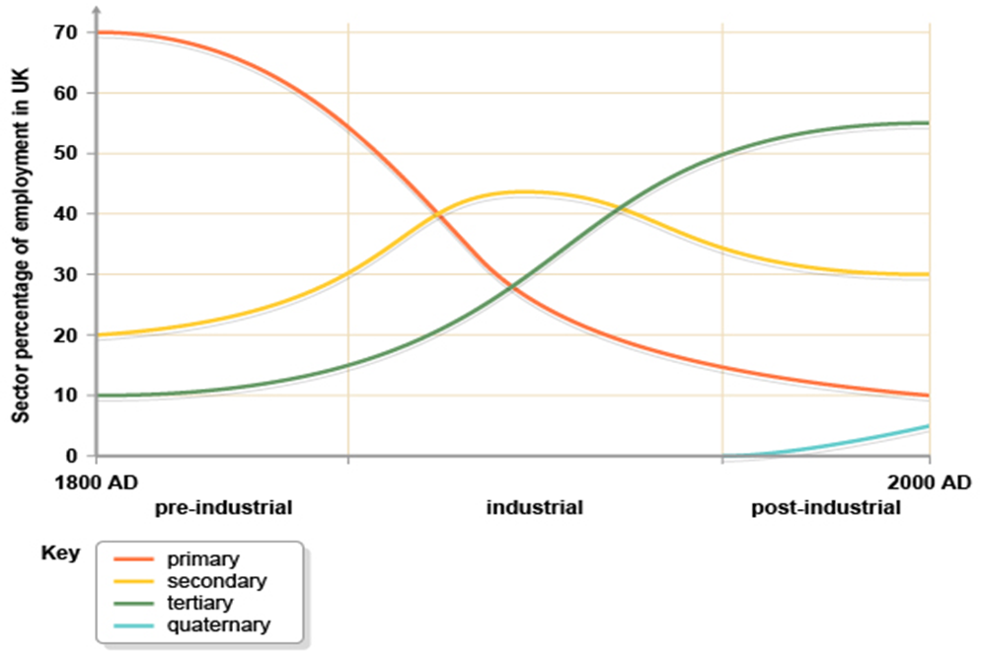
Task 2: The Clark Fisher Model:

Pre-Industrial
Industrial
Post-Industrial

Task 3: Comparing Economies
Compare the economies of Malawi, Vietnam and the UK. Annotate (label) around the table what you notice.

Explain how:
- Industrialisation has given Vietnam a higher GDP than Vietnam.
Vietnam has invested more in factories, therefore…
_____________________________________________________________________________________________________________________________________________________________________________________________________________________________________________________________________________________________
- The UK has a much higher GDP than Vietnam, even though its manufacturing (industry) is lower.
The UK has a much higher GDP than Vietnam because…
_____________________________________________________________________________________________________________________________________________________________________________________________________________________________________________________________________________________________

Glossary Unit 2: Development Dynamics
Key Term | Definition
Biogas | a gas produced by the breakdown of organic matter, such as manure or sewage, in the absence of oxygen. It can be used as a biofuel
Bottom-up development | experts work with communities to identify their needs, offer assistance and let people have more control over their lives, often run by non-governmental organisations
Cash crops | crops sold for cash, directly from farmers to be exported and traded on global markets
Caste-based society | the Hindu caste system determines a person’s status (and job), a social custom found traditional rural villages in India
Clark Fisher model | theory produced by two economists, Clark and Fisher, that explains changes in employment structure as countries develop their economies
Colonisation | when another country takes over a foreign land and applies a system of power
Commodities | items of value that can be traded for money
Communism | is a system of government, based on the theories of Karl Marx, which believes in sharing wealth between all people
Containerization | the transport of goods using container ships
Core region | areas within a country that are important economic hubs, with high levels of employment and technological innovation
Cycle of poverty | a set of factors that cause continuous poverty unless intervention is made
Demographic data | all data linked to population e.g. birth rate, death rate etc.
Dependency ratio | the proportion of people below (aged 0-14) and above (over 65) normal working age. The lower the number, the greater the number of people who work and are less dependent
Development indicators | measures of how a country is improving
Economic liberalisation | when a country's economy is given the freedom of a 'market economy', consumers and companies decide what people buy based on demand
Emerging countries | a country with high-to-medium human development, and recent economic growth
Emerging economies | countries that have recently industrialised and are progressing towards an increased role in the world economy
Fertility rate | average number of births per woman
Footloose | term used to describe companies that are able to locate anywhere there is high-quality communication links
Foreign Direct Investment (FDI) | unrestricted flows of capital (money) from one country to another
Frank’s dependency theory | theory developed by economist André Frank that describes development using two types of global region (core and periphery)
Global north | a group of wealthy countries found mainly in the Northern hemisphere
Global south | a group of less wealthy countries found mainly in the Southern hemisphere
Gross Domestic Product (GDP) | the total value of *goods and *services produced by a country in one year
Globalisation | increased connections between countries
High Income Countries (HICs) | countries where employment is dominated by tertiary and quaternary sectors
Human Development Index (HDI) | a standard means of measuring human development
Industrialisation | where a mainly agricultural society changes and begins to depend on manufacturing industries instead
Infant mortality | number of children per 1000 live births who die before their first birthday
Infrastructure | the basic services needed for an industrial country to operate e.g. roads, railways, power and water supplies, waste disposal, schools, hospitals, telephones and communication services
Inter-Governmental Organisations (IGOs) | governments and agencies working together
Intermediate technology | uses low-tech solutions using local materials, labour and expertise to solve problems
Irrigation | is the artificial watering of land that allows farming to take place
Knowledge economy | an economy based on specialised knowledge and skill
Level of development | means a country's wealth (measured by its GDP), and its social and political progress (e.g. its education, health care or democratic process in which everyone can vote freely
Maternal mortality | number of mothers per 100 000 who die in childbirth
Life expectancy | average number of years a person can expect to live
Low Income Countries (LICs) | countries where employment is dominated by the primary sector e.g. farming
Middle Income Countries (MICs) | countries dominated by the secondary sector (manufacturing), which often have large reserves of raw materials which has encouraged investment and growth e.g. Brazil and Chile
Multiplier effect | when people or businesses move to an area and invest money on housing and services, which in turn creates more jobs and attracts more people
Neo-colonialism | ‘new’ colonialism
New economy | economy based on the sale of services, rather than manufactured products
Newly Industrialising Countries (NICs) | the name given to countries that have very recently started to rapidly develop, such as Hong Kong, Singapore and Malaysia (the ‘Asian Tigers’)
Non-governmental organisations (NGOs) | NGOs work to make life better, especially for the poor. Oxfam, the Red Cross and Greenpeace are all NGOs
Outsourcing | using people in other countries to provide services if they can do so more cheaply e.g. call centres
Population structure | the number of each sex in each age group (e.g. 10-14), usually displayed in a population pyramid diagram
Primary products | raw materials
Purchasing power parity (PPP) | shows what you can buy in each country, now used to measure GDP
Rostow’s theory | theory by Walt Rostow about the economic growth of countries
Quaternary sector | employment based on highly specialised knowledge and skill
Quintile | a group of five
Recently Industrialising Countries (RICs) | countries such as China and India which have recently industrialised
Rural-urban migration | the movement of people from the countryside to the cities, normally to escape from poverty and to search for work
Secondary products | manufactured goods
Secondary sector | employment based in manufacturing
Subsistence farming | where farmers grow food to feed their families, rather than to sell
Tariff | additional cost added to the price of traded goods
Terms of trade | means the value of a country's exports relative to that of its imports
Tertiary sector | employment based on services
Top-down development | when decision-making about the development of a place is done by governments or large companies
Trans National Companies (TNCs) | those which operate across more than one country
World Trade Organisation (WTO) | a global organisation dedicated to making trade between countries easier

