Topic 7 – People and the Biosphere
- Explain how latitude affects temperature and precipitation distribution (4)
__________________________________________________________________________________________________________________________________________________________________________________________________________________________________________________________________________________________________________________________________________________________________________________________________________________________________________________________________________________________________________________________________________________________________________________________________________________________________________________________________________________________________________________________________________________________________
- Below is the climate graph data for Kenya, refer to the graph when answering the following questions
Climate graph of Kenya
Annual temperature and precipitation of Kenya
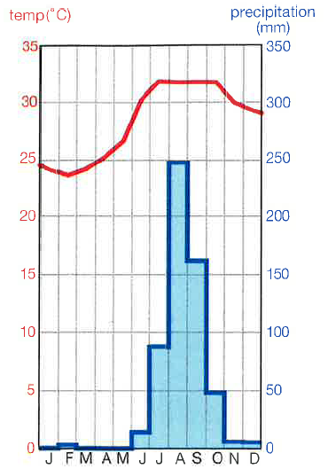

- Which month experiences the highest amount of precipitation, include figures and units (2)
_________________________________________________________________________________
- Name the four months which experience the highest temperature at 32°C? (2)
_______________________________________________________________________________
- Describe the pattern of Kenya’s climate (2)
____________________________________________________________________________________________________________________________________________________________________________________________________________________________________________________________________________________________________________________________________________________________________________________________________________________________________________________________________________________________________________
- Define the term biodiversity (1)
______________________________________________________________________________________________________________________________________________________________________________________________________________________________________________________
- Define the term biome (1)
______________________________________________________________________________________________________________________________________________________________________________________________________________________________________________________
- State two differences between the theories of population and resource consumption - Malthus and Boserup (4)
____________________________________________________________________________________________________________________________________________________________________________________________________________________________________________________________________________________________________________________________________________________________________________________________________________________________________________________________________________________________________________________________________________________________________________________________________________________________________________________________________________________________________________________________________________________________________________________________________________________________________________________
- Biomes are being destroyed at different rates, shown in the graph below. Refer to the information on the graph to support your answers
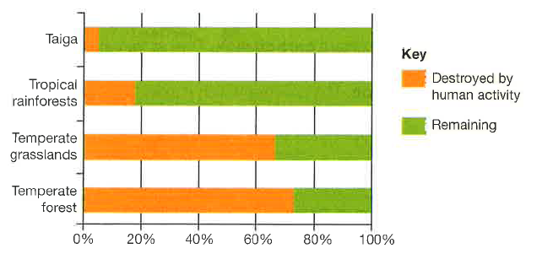

- Which biome has experienced the least amount of damage caused by human activity, include the name and the figure (2)
____________________________________________________________________________________________________________________________________________________________________

- State two reasons as to why humans are destroying the biomes for commercial gain (2)
________________________________________________________________________________________________________________________________________________________________________________________________________________________________________________________________________________________________________________________________________

- Explain how humans are interfering with the global services a biome provides. Refer to healthy air, water quality and soil quality (6)
__________________________________________________________________________________________________________________________________________________________________________________________________________________________________________________________________________________________________________________________________________________________________________________________________________________________________________________________________________________________________________________________________________________________________________________________________________________________________________________________________________________________________________________________________________________________________________________________________________________________________________________________________________________________________________________________________________________________________________________________________________________________________________________________________________________________________________________________________________________________________________________________________________________________________________________________________________________________________________________________________________________________________________________________________________________________________________________________________________________________________________________________________________________________________________________________________________________________________________________________________________________________________________________________________________________________________________________________________________________________________________________________________________________________________________________________________________________________________________________________________________________________________________________________________________________________________________________________________________________________________________________________________________________________________________________________________________________________________________________________________________________________________________________________________________________________________________________________________________

