Component 2 – Paper 2 exam for Topics 4, 5, and 6
Topic 4: The UK’s Evolving Physical Landscape

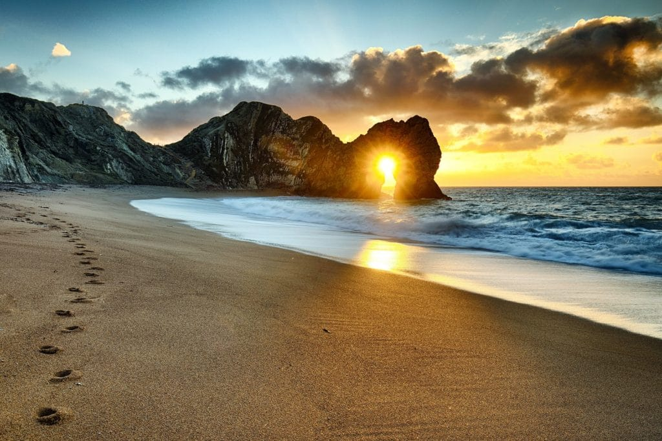
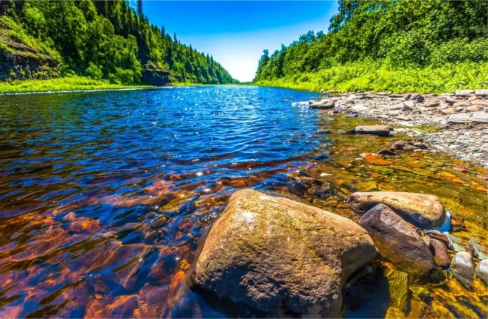

Instructions
1. You will need to use either your revision guide, the knowledge organisers that are on the Show My Homework post, or the department’s website: http://www.fulstonmanorgeoggers.weebly.com
2. You are to read carefully the task set on each page and then complete the task in full sentences where expected.
3. If you get stuck, remember the three Bs – Book, Brain, Boss!
Book - Check your resources first (revision guide, knowledge organiser, website)
Brain – Think it through, you may really already know but are doubting yourself
Boss – email your teacher, message them on Show My Homework, or on Google Classroom for support

UK Physical Landscapes
Key words
Upland area ___________________________________________________________
Lowland area __________________________________________________________
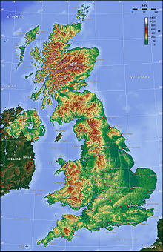
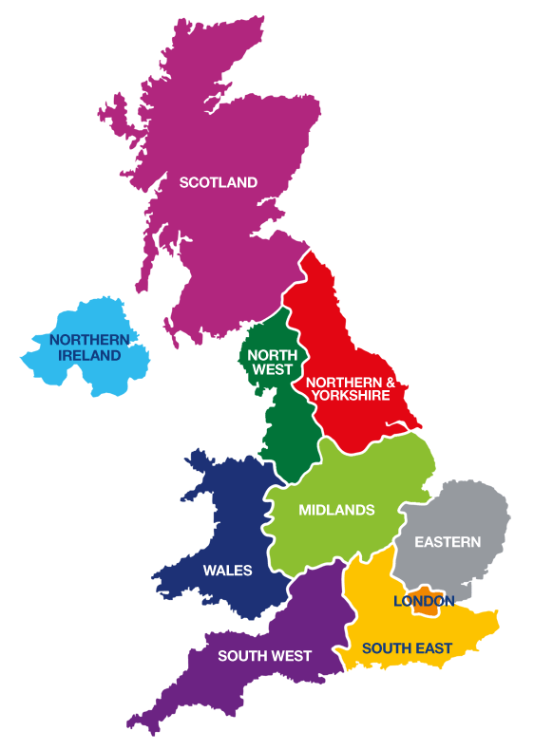
Relief of the land _______________________________________________________
Describe the location of the lowland areas (dark green) (Use compass directions, as well as countries of the UK)
______________________________________________________________________________________________________________________________________________
Describe the location of the upland areas (brown) (Use compass directions, as well as countries of the UK)
___________________________________________________________________________________________________________________________________________________
Rock types of the UK
Describe the key differences between the different rock types found in the UK.
__________________________________
_______________________________
_______________________________
_______________________________
_______________________________

Coastal Landscapes

Waves
What causes a wave?
____________________________________________________________________________________________________________________________________________________________________________________________________________________________________________________________________________________
What is the fetch?
__________________________________________________________________________________________________________________________________________
Types of waves
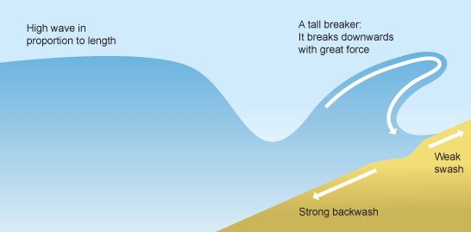
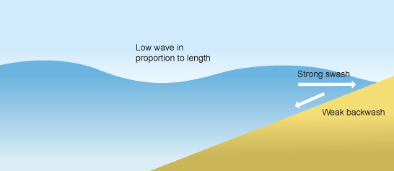
There are two types of waves: constructive and destructive. Complete the table below to show the characteristics of each wave using the image to help you:
Constructive
Destructive

Wave characteristic | Constructive wave | Destructive wave
Which has the highest waves?
Strength of swash
Strength of backwash
Beach sediment – gain or loss

Weathering
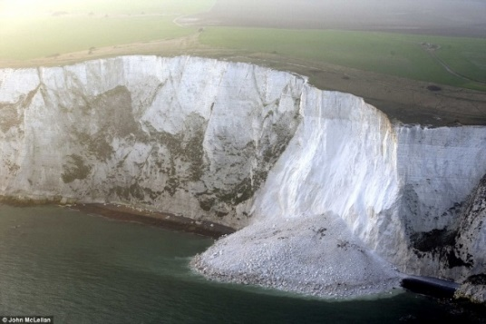
What is weathering?
_________________________________________
What is mechanical (physical) weathering?
__________________________________________________________________________________________________________________________________________
What is chemical weathering?
__________________________________________________________________________________________________________________________________________
What is mass movement?
__________________________________________________________________________________________________________________________________________
Complete the simple diagrams and definitions to show the different types of mass movement:
Fall (Eg Rockfall) | Slide (Eg landslide)
Slump

Erosion
Complete the table below describing the four types of erosion found at the coast:
Hydraulic action | Abrasion
Attrition | Solution

Transportation
Do the same in the table below to describe the four types of transportation found at the coast:
Traction | Saltation
Suspension | Solution
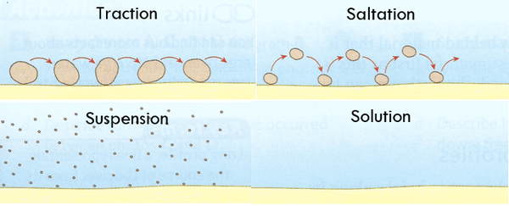
Destructive

Draw an annotated diagram in the box below to explain the process of longshore drift:

Deposition
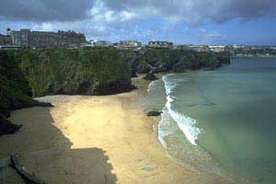
What is coastal deposition?
__________________________________________________________________________________________________________________________________________
Give 2 reasons why coastal deposition occurs:
- ________________________________________________________________________________________________________________________________
- ________________________________________________________________________________________________________________________________

Landforms created by erosion
Landforms at the coast are the result of rock type (hard and soft) as well as physical processes (Erosion or deposition)
Headlands and Bays
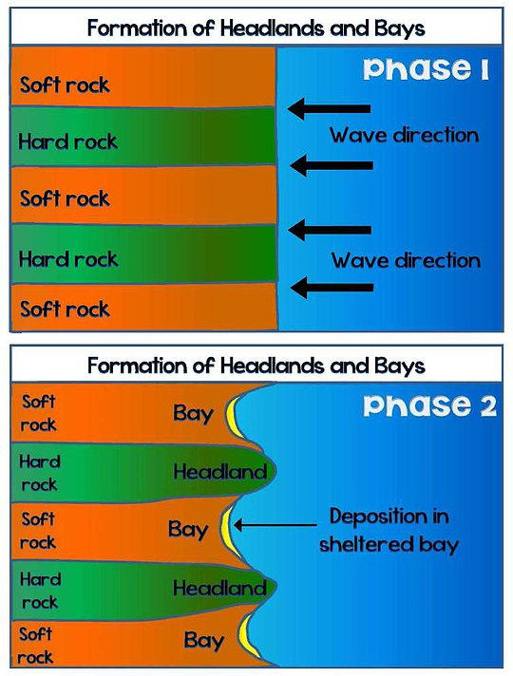
Give an example in the UK
__________________________________________

Explain how headlands and bays form
(using the diagram to help you. Remember to include key terms where necessary)
__________________________________________________________________________________________________________________________________________________________________________________________________________________________________________________________________________________________________________________________________________________________________________________________________________________________________________________________________________________________________________________________________________________________________________________________________________________________________________________________________________________________________________________
Challenge!
What is wave refraction?
____________________________________________________________________________________________________________________________________________________________________________________________________________________________________________________________________________________
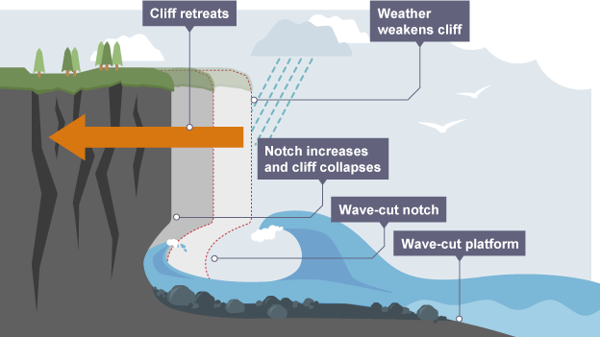
Cliffs and wave-cut platforms
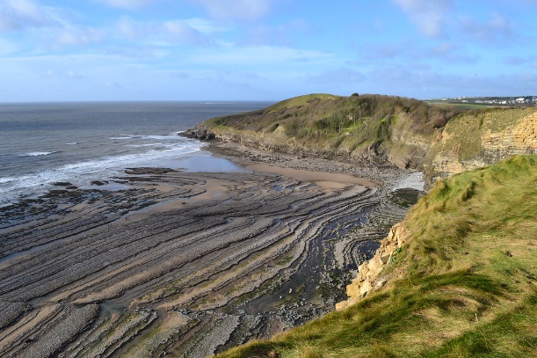

Complete annotated diagrams below to explain how a wave-cut platform is created (Remember to include the erosional processes!)
Step 1 | Step 2
Step 3 | Step 4

Caves, cave, arches, stacks and stumps
Name an example in the UK _____________________________________________________________________
Explain how each one causes the next. The first one has been done for you (Remember to include the erosional processes!)

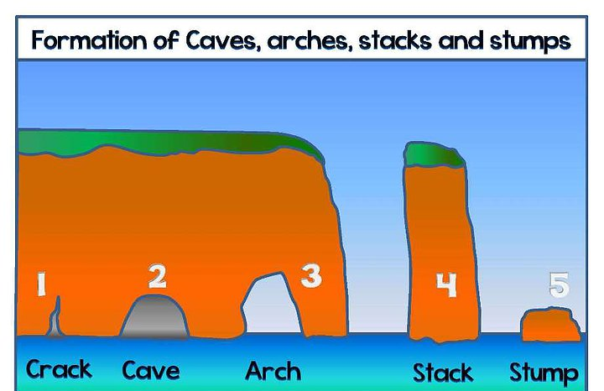

A crack opens up in a headland due to hydraulic action opening up a weakness in the rock

Landforms created by deposition
Landforms at the coast are the result of rock type (hard and soft) as well as physical processes (Erosion or deposition)
Beaches
Beaches are deposits of sand and shingle at the coast. Explain how both sandy and pebbly beaches form:
Sandy: _______________________________________________________________ __________________________________________________________________________________________________________________________________________
Shingle/pebble: ________________________________________________________ __________________________________________________________________________________________________________________________________________

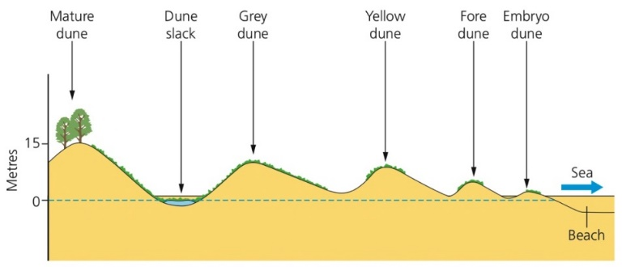
Sand dunes
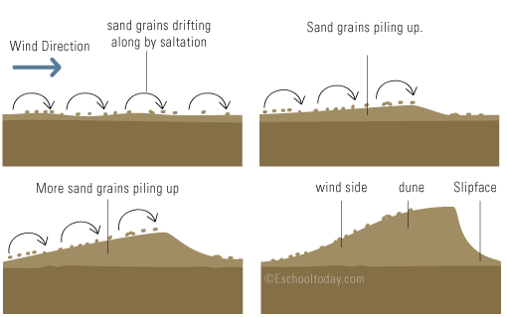
Explain the formation of sand dunes
Step 1 ________________________________________________________________
_____________________________________________________________________
Step 2 ________________________________________________________________
_____________________________________________________________________
Step 3 ________________________________________________________________
_____________________________________________________________________
Step 4 ________________________________________________________________
_____________________________________________________________________

Spits and Bars
Spits are long, narrow fingers of sand or shingle jutting out into the sea. A bar is a spit that has grown across a bay.
Example in the UK _______________________________________________________
Draw an annotated diagram in the box below to explain the formation of spits and bars

Drawing (1) | Explanation
Drawing (2) | Explanation
Drawing (3) | Explanation
Drawing (4) | Explanation
Drawing (5) | Explanation

Managing Coastal Erosion
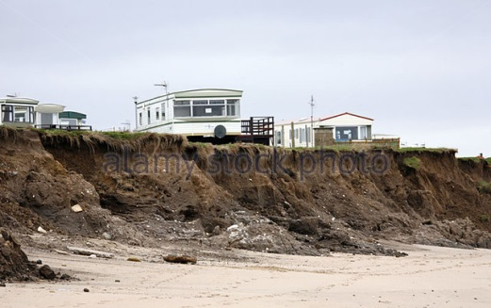
Different management strategies can be used to protect coastlines from the effects of physical processes
Hard engineering: __________________________________________________________________________________________________________________________________________
Soft engineering: _______________________________________________________ __________________________________________________________________________________________________________________________________________
Managed retreat: _______________________________________________________ _____________________________________________________________________
Complete the tables explaining how these methods work and colour code into hard and soft
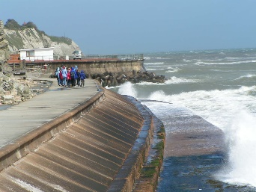  Sea Wall | 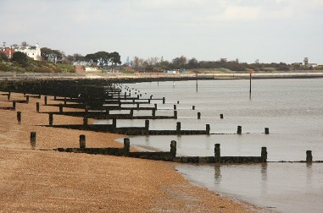  Groynes
How does it work? | How does it work?
Advantages | Advantages
Disadvantages | Disadvantages

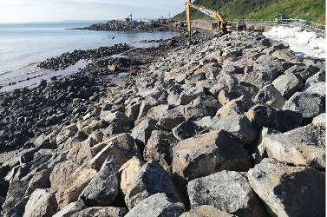  Rock Armour | 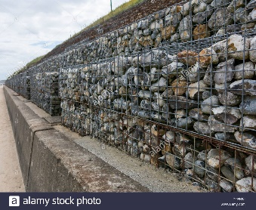  Gabions
How does it work? | How does it work?
Advantages | Advantages
Disadvantages | Disadvantages

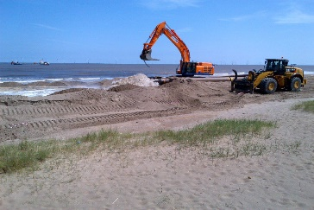  Beach nourishment | 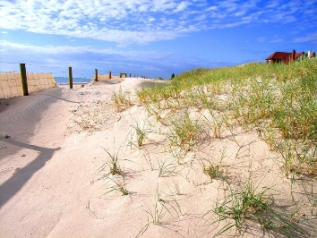  Sand dune regeneration
How does it work? | How does it work?
Advantages | Advantages
Disadvantages | Disadvantages
Cliff stabilisation | 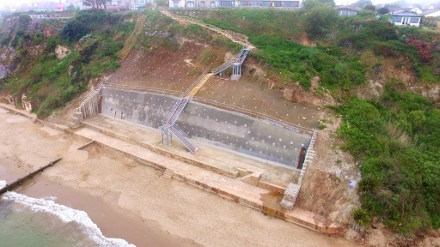
How does it work?

Advantages | Disadvantages

An example of a coastal management scheme in the UK: Lyme Regis
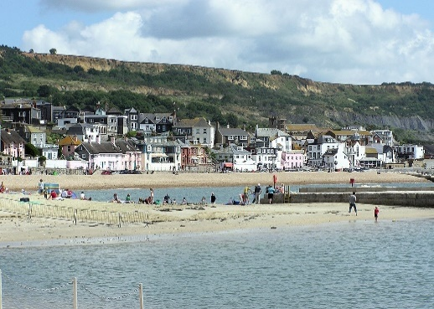
Why does the Lyme Regis need protecting?
____________________________________________________________________________________________________________________________________________________________________________________________________________________________________________________________________________________
List 4 specific strategies used in the Lyme Regis to protect the coastline:
- ________________________________________________________________
- ________________________________________________________________
- ________________________________________________________________
- ________________________________________________________________

What are the positive and negative impacts of the defences on the area?
Positive impacts | Negative impacts

River Landscapes
Features of a river
Annotate on the definitions of the key words of a drainage basin
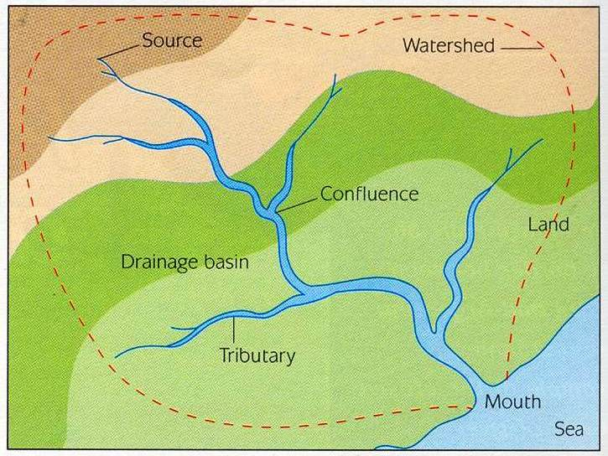
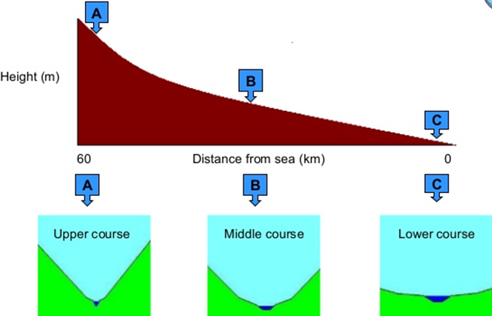
The long profile
The shape of river valleys changes as rivers flow downstream
The long profile of the river is __________________________________________________________________________________________________________________________________________
The shape of it is _________________________There are three parts to the river _______________________________________________________________________________________________________________________________________________________________________________________________________________
The cross-profile
The cross profile of the river is _____________________________________________
_____________________________________________________________________
The cross-profile of the river changes. Describe what happens to the width and the depth
 | Width | Depth | Main process found here
Upper course
Middle course
Lower course

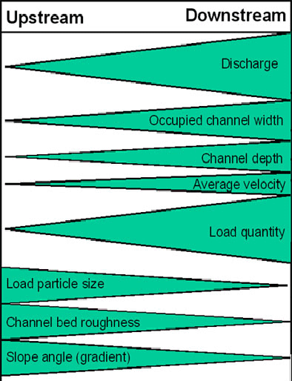
Bradshaw Model
The Bradshaw model looks at the changes in the river from the upper course to the lower course
What things are expected to increase?

What things are expected to decrease?

River discharge increases because ___________________________________________
_____________________________________________________________________Velocity of the river increases because ________________________________________
_____________________________________________________________________Particle size decreases because _____________________________________________
_____________________________________________________________________
Upper Course of the river
The main process here is __________. As well as the 4 types of erosion. Erosion can go vertically (Cutting downwards) or horizontally (laterally – Going sideward). It is these processes that change the shape of the cross profile from the source (Upper course) to the mouth (lower course).
Complete the table below describing the four types of erosion found in a river:
Hydraulic action | Abrasion
Attrition | Solution

V shaped Valleys and interlocking spurs
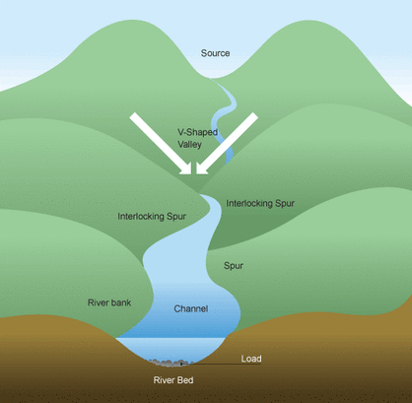
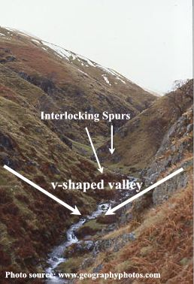
Explain the formation of V shaped valleys and interlocking spurs (don’t forget to include erosional processes!) __________________________________________________________________________________________________________________________________________________________________________________________________________________________________________________________________________________________________________________________________________________________________________________________________________________________________________________________________________________________________________________________________________________________________________________________________________________________________________________________________________________________________________________

Waterfalls and gorges
Explain and use diagrams below to explain the formation of waterfalls and gorges: (don’t forget to include erosional processes!)

Step 1
Step 2
Step 3
Step 4
Step 5
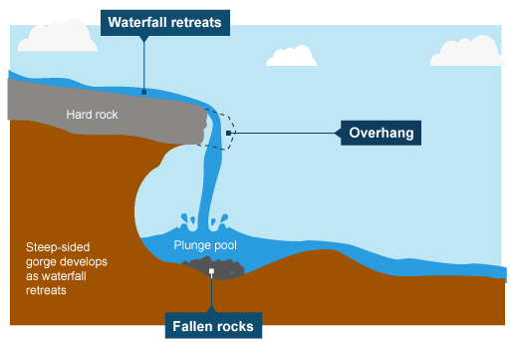

Middle Course of the river
Features are formed by erosion and deposition in the middle course of a river. Much of the material eroded in the upper course gets transported through the middle course.
Describe the four types of transportation in a river:
Traction | Saltation
Suspension | Solution

Meanders
Meanders are _________________________________________________________
Their cross profile is asymmetrical (not the same on both sides).
Draw the cross section and label with the key words

- Outside of the river
- Inside of the river
- Fastest flow of water (Thalweg)
- Centrifugal force (Force making the water go to the outside)
- River cliff
- Slip off slope

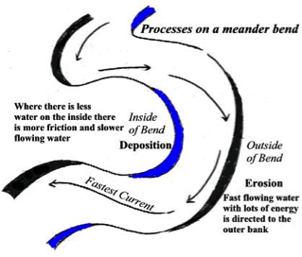
Using the diagram to help, explain the formation of a meander
_____________________________________________________________________________________________________________________________________________________________________________________________________________________________________________________________________________________________________________________________________________________________________________________________________________________________________________________________________________________________________________________________________________________________________________________________________________________________________________
Ox Bow Lakes
Draw and explain the formation of ox-bow lakes:
Step 1
Step 2
Step 3
Step 4

Lower course of the river
The river here is its widest and deepest. The river here also flows the fastest, but where it meets the sea, the different types of water (fresh vs salty) causes the river to deposit the material.
Material is also deposited when the river floods.
Levees and floodplains
Draw annotated diagrams below to explain the formation of levees and floodplains:

When a river floods it…

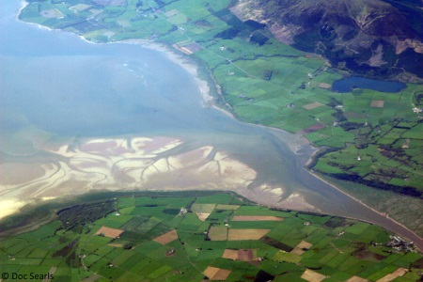
Estuaries
These are found where rivers meet the _______. The two waters are different densities and salt quantities and mix together to create a type of water known as ______________ water. Here, _________________ happens and sediment is first deposited to form ________________. Overtime sediment can grow on them and _________________ grow in parts of the estuary.
Words include salt marsh, mudflats, deposition and brackish
An example of a river valley in the UK: River Mersey
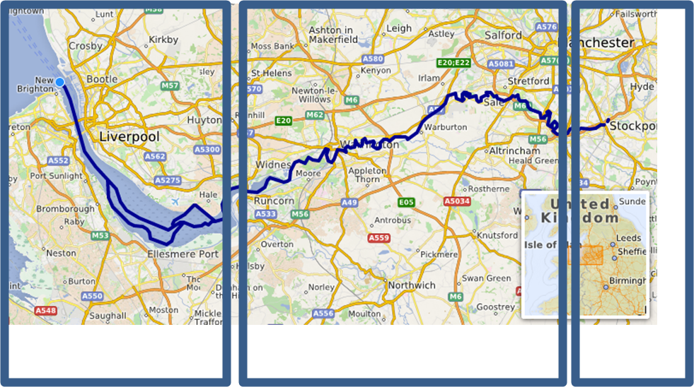
Identify which section of the river is the upper, middle and lower (Write them underneath)
What places are in each of the sections?
Upper ___________________________________________________
Middle __________________________________________________
Lower __________________________________________________
What landforms would be found in each of the sections?
Upper ___________________________________________________
Middle __________________________________________________
Lower __________________________________________________

River flooding
Explain some physical and human causes of flooding – make sure you can explain how each one leads to flooding:
Physical/Natural | Human
Heavy rainfall = | Urbanisation =
Rock type = | Deforestation =
Gradient of land = | River management =

Flood hydrographs

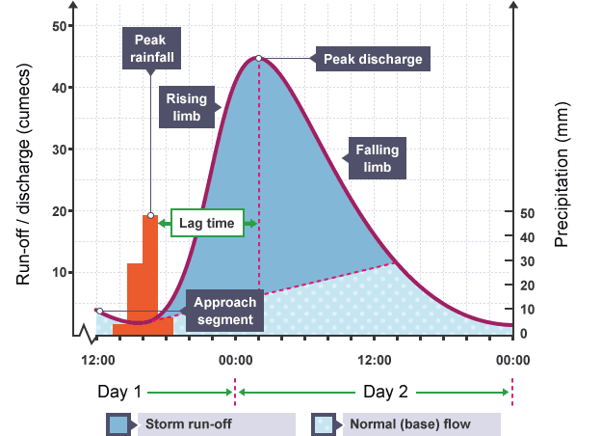
Discharge _____________________________________________________________
Lag time ______________________________________________________________
How would you describe the shape of this hydrograph? ____________________________
Is this river likely to flood? ________________________________________________

Flood management
What is hard and soft engineering?
Hard engineering is ______________________________________________________ _____________________________________________________________________
Soft engineering is ______________________________________________________ _____________________________________________________________________
Complete the tables explaining how these methods work and colour code into hard and soft
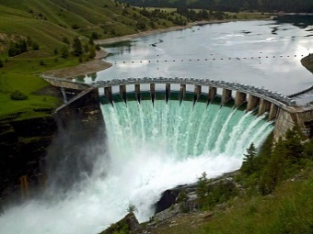  Dams/ reservoirs | 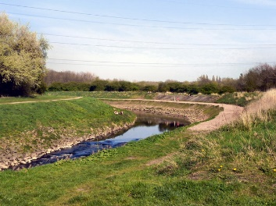  Levees
How does it work? | How does it work?
Advantages | Advantages
Disadvantages | Disadvantages

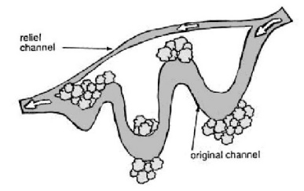  Flood relief channels | 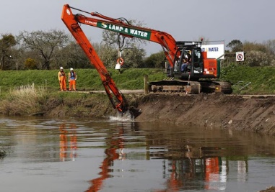  Dredging
How does it work? | How does it work?
Advantages | Advantages
Disadvantages | Disadvantages

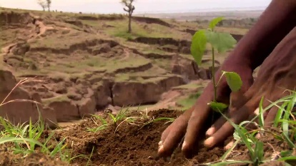  Afforestation | 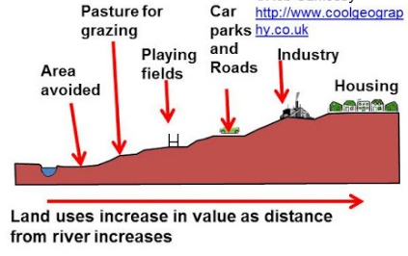  Flood plain zoning
How does it work? | How does it work?
Advantages | Advantages
Disadvantages | Disadvantages

An example of a flood management scheme in the UK: Somerset Levels
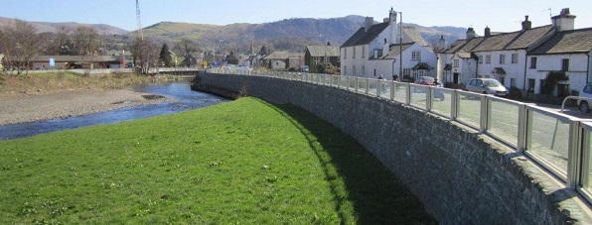
Why did Somerset need a flood management project?
____________________________________________________________________________________________________________________________________________________________________________________________________________________________________________________________________________________
Describe 4 of the strategies used in Somerset to reduce the risk of flooding:
- ________________________________________________________________
- ________________________________________________________________
- ________________________________________________________________
- ________________________________________________________________

Complete the table below showing the costs (disadvantages) and benefits (advantages) of the scheme.
 | Social | Economic | Environmental
😊
☹

