Name Teacher
Year 9 Geography Plate
Tectonics

Hello year 9 Geographers! Well done on completing the work set so far. This new booklet focuses on Plate Tectonics. The study of processes within the Earth that create amazing features such as Earthquakes and volcanoes

All the work in here can be done on paper if you can’t print a copy.

Please keep completed work to show us how hard you have been working when we return to School.

In addition to the work provided, here are some great links to Geography resources you’ll
find helpful and interesting. Keep up the hard work!
Mrs Mitchell, Miss Finn, Mr Gest, Mr Prutton, and Mr Westby

www.timeforgeography.co.uk/ Fantastic library of videos about our world

www.bbc.co.uk/bitesize/subjects/zrw76sg BBC bitesize Geography with links to all the topics, activities and daily lessons.

Lesson 1: Essential knowledge 1

The Earth’s crust is broken up into lots of plates. These slowly move over time due to
convection currents in the Earth. Where 2 plates meet is called a plate boundary or plate margin. Watch this video and then read over this information from the BBC.

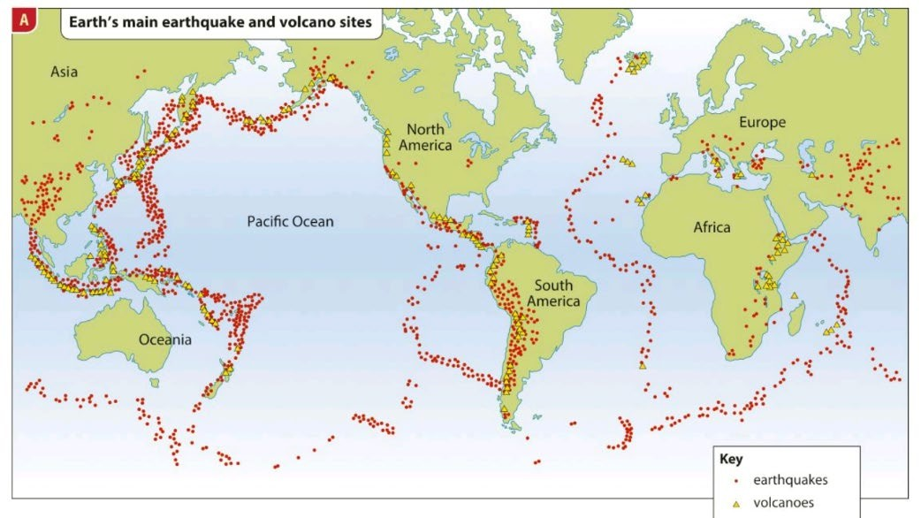
Almost all of the world’s Earthquakes and volcanoes can be found at plate boundaries.
1. The theory of plate tectonics is that….

____________________________________________________________________________

____________________________________________________________________________

____________________________________________________________________________

____________________________________________________________________________

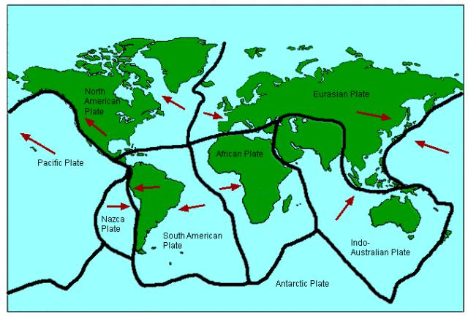
2. Look at the map. The black lines show plate margins. In one sentence, say what a plate margin is.

_________________________________________________________

_________________________________________________________

_________________________________________________________

_________________________________________________________

3. Why do most earthquakes and volcanoes occur near plate margins? In your answer, try to use geographical terms such as: convection currents, tectonic plates, plate boundaries, collision, energy, etc.

____________________________________________________________________________

____________________________________________________________________________

____________________________________________________________________________

4. Where do more tectonic hazards occur? Circle the correct answers.

  - On or near plate margins / far from plate margins

  - Near the Pacific Ring of Fire / far from the Pacific Ring of Fire

  - Near coastal areas / inland areas

  - The western coastline of North and South America / the eastern coastline of North and South America

  - Southern Africa / south and eastern Asia

5. There are three main types of plate margin (destructive, constructive and conservative). For each plate margin type:
  - Draw a diagram showing how the plates move (Towards each other? Apart? Alongside each other?)

  - Write a sentence describing what happens
  - Indicate whether earthquakes and/or volcanic eruptions occur as a result

  - Give an example (use the map above to help you) e.g. ‘where the South American and Nazca plates meet’

Activity 2 Exam Question

Answer this question using the map above

Describe the location of Earthquakes and volcanoes on Earth (4)

- To get full marks you need to say where Earthquakes and Volcanoes can be found using compass directions and names of oceans and continents. You have a map in your planner.

Literacy Help
Sentence starter: Earthquakes are located in…. Volcanoes are located in… Key words: Oceans, Atlantic, Pacific, Continents, North America, Asia Discourse markers: As well as, in addition, likewise

Lesson 2: Essential knowledge Plate boundaries – Watch this video first.

You will need to be able to draw diagrams and write descriptions of each type of boundary.

Constructive
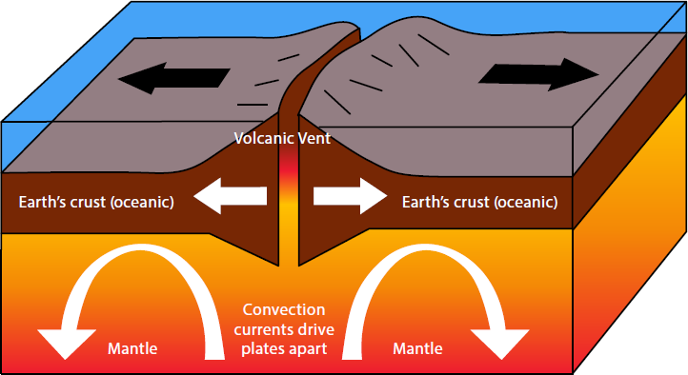
Draw a diagram of a constructive boundary

Activity 1 Describe the features of a constructive boundary using the diagram to help you. Include all the information from the diagram.

Destructive
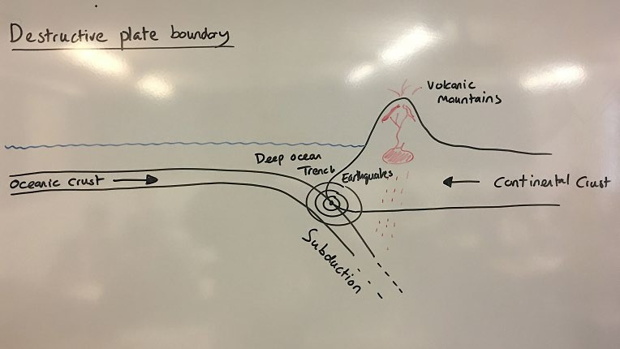
Draw a diagram of a destructive boundary

Activity 2 Describe the features of a destructive boundary using the diagram to help you. Include all the information from the diagram.

Collision
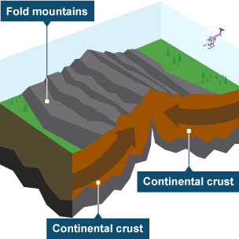

Draw a diagram of a collision boundary

Activity 3 Describe the features of a collision boundary using the diagram to help you. Include all the information from the diagram.

Conservative
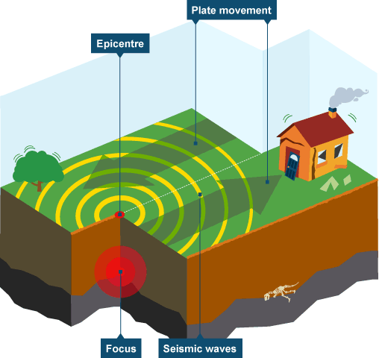
Draw a diagram of a conservative boundary

Activity 4 Describe the features of a conservative boundary using the diagram to help you. Include all the information from the diagram.

Lesson 3 Research lesson

Japan, Nepal and Chile are all countries affected by Earthquakes. Using the internet research an Earthquake that affected one of them, You should find out:
Responses to the Earthquake:
Other effects:
Magnitude: Location:
Number of deaths:
Time:
Date:

Activity 2 Exam question. Use your research to help you.

Describe the location and effects of an Earthquake you have studied. (4)

Literacy help
Sentence starter: One Earthquake I studied was…this happened in… some of the effects were…..
Key words: Magnitude, effects, responses,
Discourse markers: For example, in addition, furthermore, such as.

Lesson 4: Essential knowledge 1 Primary and Secondary effects

Earthquakes have primary and secondary effects.
Primary effects are what the earthquake actually does. For example destroy homes.

Secondary effects are the knock on effect of this. For example as homes have been destroyed people are made homeless.

Watch this video about the earthquake in Haiti in 2010 – note there are images and details that you may find disturbing, if this is the case click here instead.

Activity 1. Read the information and complete the task below.

Label each of these as a primary or secondary effect (if you are working on paper make a list). They are all from the Haiti Earthquake in 2010

220 000 people were killed | Stealing became a serious problem
People who lost their homes were moved into  tents and temporary shelters. | 100 000 homes were destroyed.
The destruction of the Government  buildings hindered the government’s efforts to control Haiti and the police force collapsed. | The Haitian tourist industry declined as  tourists stopped visiting.
300 000 people were injured | By November 2010 there were outbreaks of  diseases such as cholera.
The main shipping port was badly damaged  and part of it collapsed into the sea. | Eight hospitals or health care centres in  Port-au-Prince were badly damaged or collapsed.

Activity 2 Exam Question (4 marks)

Describe the effects of the Haiti earthquake. (tip describe the primary and secondary effects)

Lesson 5: Essential knowledge - Answering evaluation questions.

Questions that ask you to evaluate something are worth the most marks at GCSE, either 8 or 12. Evaluation involves explaining the positives about something, then the negatives and then come to a conclusion.

It doesn’t matter what your conclusion is, positive or negative as long as you can give reasons for your decision.

You can break it down into 3 PEE paragraphs Positive PEE
Negative PEE Conclusion PEE
You are going to use some resources to practice answering an evaluation question.

Activity 3 Exam question 8 marks

The primary effects of the Haiti Earthquake were more devastating than the secondary effects. Evaluate this statement (8)

You need to decide if this statement is true or not. Begin by explaining why you agree with the statement

PEE Paragraph 1. Why you agree

P I agree that the primary effects were more serious, for example one primary effect was……..

E This was devastating because…..

E Therefore……..

PEE Paragraph 2 Why you disagree

P However the secondary effects could be very devastating, for example one secondary effect was

E This was devastating because…..

E Therefore……..

PEE Paragraph 3 Conclusion (decide if you agree or disagree)

P Overall I agree/disagree

E The main reason I think this is……………………..

E Someone may disagree with me because……………..

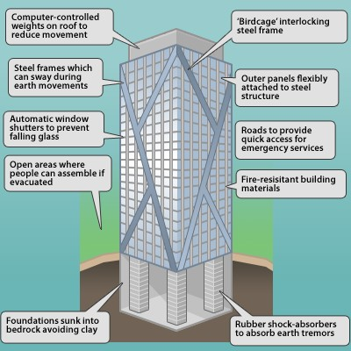
Lesson 6: Essential knowledge Earthquake resistant buildings – Watch this video first

Activity 1 Using the information answer this exam question.

Explain how buildings can be made earthquake resistant (4 marks)

P: One way in which a building can be made earthquake resistant is…….

E: This makes the building resistant because……

P: Another way in which a building can be made earthquake resistant is…….

E: This makes the building resistant because……

P: A final way in which a building can be made earthquake resistant
is…….

E: This makes the building resistant because……

Extension – try out this disaster simulation and record what you find out about the different methods that can be used to protect and prepare people for an earthquake.

Lesson 7: Tsunami – watch this video first and then answer the questions below.

The Earthquake – all answers are based on the report as it happened:

1. The earthquake hit Japan on ______________________________________.

2. It registered a magnitude of _____________________________________.

3. That makes it the most powerful quake to hit Japan in at least _____________ years.

4. There were reports over the weekend that the quake moved the main island of Japan by ________ feet.

5. Scientists in Japan say that there is a strong change of another quake, one with a magnitude of __________ or higher, hitting in the next few days.

The Tsunami – answer the questions in complete sentences
6. Which part of the country was most affected by the tsunami?

______________________________________________________________________

7. What is a tsunami?

______________________________________________________________________

8. How fast can a tsunami travel?

_____________________________________________________________________

9. How far away did the tsunami travel before it reached the California coast?

_____________________________________________________________________

10. What effect did the tsunami have on the boast at Santa Cruz, California?

_____________________________________________________________________
The Prime Minister’s statement
11. What expression did Japan’s Prime Minister use to describe the impact of this earthquake?

_______________________________________________________________________

12. How is the government planning to save electricity until the power plants are repaired?

_______________________________________________________________________

13. According to the Prime Minister, what is Japan’s main goal right now?

________________________________________________________________________

The Fukushima nuclear plant

14. What is nuclear fission?

15. How many reactors were running in the nuclear plant when the quake hit?

________________________________________________________________________

16. What caused the failure of the back-up generators (according to experts)?

________________________________________________________________________

17. What could happen if too much radiation gets out of the reactor?

________________________________________________________________________

The world is coming to Japan’s aid

18. How many countries offered to help?

________________________________________________________________________

19. Name three international aid groups which were also involved.

________________________________________________________________________

Lesson 8: What about volcanoes? Read the key information below.

Activity 2: Answer the following questions based on your reading.
1. Photo C from the previous page show the Soufriere Hills volcano on Montserrat. It began erupting in 1995. It has been active ever since.
a. That town (called Plymouth) has been abandoned. Why?
__________________________________________________________________________________________________________________________________________________________________________________________________________________
b. What do you think is in the big dark cloud in photo C?
__________________________________________________________________________________________________________________________________________________________________________________________________________________
2. An active volcano can produce:
Showers of ash a pyroclastic flow a lava flow plumes of dust volcanic gases
a. Make a list of these below in order of danger, starting with the one you think is most dangerous.

b. Beside each item in your list, say what harm it does.

Activity 3: Creative writing task: Read this detail about the eruption on Montserrat first. Next, below, write a report describing the scenes as if you are a reporter who has landed on the island to investigate the damage caused by the eruption.

------------------------------------------------------------------------------------------------------------------------------------------------------------------------------------------------------------------------------------------------------------------------------------------------------------------------------------------------------------------------------------------------------------------------------------------------------------------------------------------------------------------------------------------------------------------------------------------------------------------------------------------------------------------------------------------------------------------------------------------------------------------------------------------------------------------------------------------------------------------------------------------------------------------------------------------------------------------------------------------------------------------------------------------------------------------------------------------------------------------------------------------------------------------------------------------------------------------------------------------------------------------------------------------------------------------------------------------------------------------------------------------------------------------------------------------------------------------------------------------------------------------------------------------------------------------------------------------------------------------------------------------------------------------------------------------------------------------------------------------------------------------------------------------------------------------------------------------------------------------------------------------------------------------------------------------------------------------------------------
Lesson 9: Revision for your end of topic exam – complete the Seneca Learning tasks set here.
Stretch and challenge tasks to further prepare you for your end of topic exam.

- Research the deadliest earthquakes and volcanoes online. Create a poster to compare the primary and secondary effects of them.
- Research an Earthquake resistant building, write a guide to the location and features of this building.
- Design your own Earthquake resistant building, use the features we have taught you but also create your own.
- Build your own erupting model volcano! See the guide on youtube.
https://www.youtube.com/watch?v=qalAKtLbjX8

Lesson 10: Complete the end of topic exam – linked here.

