Year 8

Term 3

Weather and Climate

Name____________________ Class_______________

Lesson 1: Read [over this detail from the BBC](https://www.bbc.co.uk/bitesize/guides/zsxcwmn/revision/2) about what affects our climate and then complete the tasks below.

|  |
| --- |
| Polar Maritime:  This air mass travels across the ocean from Greenland. It brings with it wet and cold air. The weather will be cold and showery. This is very common in the UK. There can be heavy showers in hilly areas. There are often strong winds and gales. |
| Returning Polar Maritime:  This air mass comes from Greenland but travels down the Atlantic Ocean picking up more moisture. It brings unstable changeable weather where there is a lot of cloud and rain showers. |
| Polar Continental:  This air mass travels across Siberia and Russia bringing cold air to the UK. It brings dry summers and snowy winters. It can bring very cold temperatures. There is a high wind chill factor. When snow falls, it can last for several days. |
| Tropical Continental:  This air mass travels up from Africa bringing with it hot dry air to the UK. It brings will it hot weather and stable conditions. There are usually storms after this air mass has moved over the UK |
| Tropical Maritime.  This air mass travels across the warmer parts of the Atlantic Ocean. It brings cloud and rain, but the weather will be warmer. This is very common. It brings thick clouds cover. There is often fog at the coasts. |
| Arctic Maritime. This air mass travels down from the Arctic. It brings with it freezing weather conditions.  In the winter, it brings wet weather and snow. This air mass is rare in summer. There is often snow in Scotland with this air mass and heavy showers. Hail is common. It is very windy. |

Air masses that affect the UK climate

1. Draw arrows onto the map and label them to show which directions the air masses come from.
2. Colour maritime air masses in blue and continental ones in red.

Now, check your understanding of this content by completing [this task](https://app.senecalearning.com/dashboard/class/6ndfx1jb5x/assignments/assignment/e06214eb-1dbe-418b-8f4a-17e6e9cae267) on Seneca Learning.

Lesson 2: First watch this [video](https://www.youtube.com/watch?v=cz9L9M9koJk). Next read [over this detail](https://www.bbc.co.uk/bitesize/guides/zsxcwmn/revision/1) from the BBC. Then fill in the table below. To finish, test your knowledge using this [quizlet test](https://quizlet.com/549505007/test). Send a screenshot of your score to your teacher.

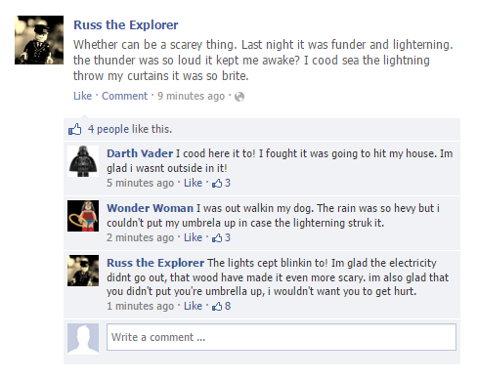

|  |  |  |
| --- | --- | --- |
| Factor | How it affects the climate | A sketch to represent this factor |
| Altitude (Relief) |  |  |
| Latitude |  |  |
| Distance from the sea (Aspect) |  |  |

Lesson 3 – Watch this [video](https://www.youtube.com/watch?v=QRThy0dsyYQ) and read [this detail](https://www.bbc.co.uk/bitesize/guides/zq2qg82/revision/2) from the BBC.

Think back to your knowledge of the water cycle from year 7. Match the key words to their definitions (Hint – there are two new terms below that you may not know – look these up).

|  |  |  |
| --- | --- | --- |
| Evaporation |  | Water held in the air as a gas |
| Microscopic particles of dust, smoke, or salt in the atmosphere on which water vapour condenses to form cloud droplets. |
| Condensation |
| Water Vapour | The process when water turns from a liquid to a gas (water vapour). |
| Condensation Nuclei | Most common wind direction |
| Prevailing Wind | The process when water vapour turns into a liquid. |

Put these statements into the correct order

|  |  |
| --- | --- |
| Statement | Order 1-5 |
| Cloud droplets are so tiny, they can stay afloat on-air currents. Billions of cloud droplets together form a cloud. |  |
| As the warm air rises, it cools. Cool air cannot hold as much water vapour as warm air. |  |
| If the cloud droplets join up to make larger, heavier droplets (around 2mm), they can fall as rain! |  |
| Water vapour condenses onto tiny dust particles (called condensation nuclei) in the air, forming a cloud droplet. |  |
| Warm air starts to rise upwards. The air contains water vapourthat has been evaporated from the sea, river, lakes, etc. |  |

Watch this [weather tutorial](https://www.youtube.com/watch?v=FMagDRCpJ14) on clouds.

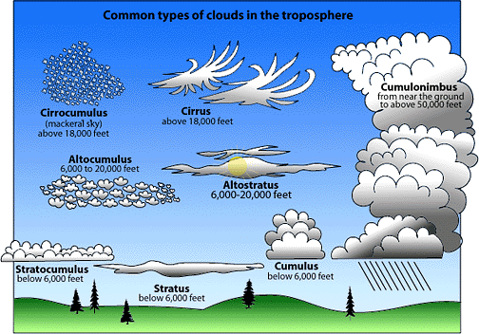Match the cloud pictures with the names below:

Stratocumulus

Cirrus

Stratus

Cumulonimbus

Altostratus

Cumulus

Cirrocumulus

Altocumulus

|  |  |  |  |
| --- | --- | --- | --- |
| http://upload.wikimedia.org/wikipedia/commons/thumb/7/73/Cirrus_clouds2.jpg/250px-Cirrus_clouds2.jpg |  |  |  |
|  |  |  |  |
|  |  |  |  |
| http://scienceforkids.kidipede.com/physics/weather/pictures/stratus.jpg |  |  |  |

Test your knowledge here using this [quizlet test](https://quizlet.com/217442816/test). Send your scores to your teacher.

Lesson 4: Read over [this detail](https://www.bbc.co.uk/bitesize/guides/zw9qtfr/revision/2) on how we measure the weather from the BBC.

Match the equipment with the descriptions, then use this to complete the table on the next page.

|  |  |  |
| --- | --- | --- |
| Thermometer icon weather sign Royalty Free Vector Image |  | Rain Gauge  Precipitation is water falling from the sky.  Measures the amount of rainfall in mm. Not only does a rain gauge measure rainfall, but also all other forms of precipitation |
| A simple wind vane indicates wind direction | Thermometer  Temperature means how hot or cold it is.  It is usually measured with a thermometer in degrees centigrade(ºC) |
| Sensors measure and record humidity | Campbell stokes recorder  Sunshine is light and warmth from the sun.  A Campbell Stokes Recorder measures sunshine.  This type of recorder is made up of a glass ball which concentrates sunshine on to a thick piece of card. The sunshine then burns a mark on the card which shows the number of hours of sunshine in the day. |
| A rain gauge measures (go on...guess!) the amount of rainfall | Weathervane  Wind direction is where the wind is blowing from.  Measures wind direction by pointing towards North, East, South or West**.** |
| Barometers measure atmospheric pressure | Barometer  Pressure is a measure of the force exerted by air.  Pressure is measured with a barometer in millibars (mb) |
| A Campbell Stokes recorder measures sunshine | Anemometer  Wind speed is how fast the wind is blowing. An anemometer measures wind speed in mph.  The most common type looks like a toy windmill. The faster the wind blows the faster the cups spin around. The wind speed is shown on a dial, just like a car's speedometer |
| Anemometers measure wind speed | Hygrometer  A hygrometer measures temperature and humidity. It measures humidity as a percentage. It measures the relative humidity of the air through evaporation. It has 2 thermometers, and it measures the amount of evaporation.  Humidity is the amount of water vapour in the air. |

|  |  |  |  |
| --- | --- | --- | --- |
| **Weather term** | **Definition** | **Usually given in** | **Measured by.** |
| Temperature | How hot or cold it is. | Degrees centigrade | Thermometer |
| Precipitation |  |  |  |
| Humidity |  |  |  |
| Wind Speed |  |  |  |
| Wind direction |  |  |  |
| Sunshine |  |  |  |
| Air Pressure |  |  |  |

|  |  |
| --- | --- |
| How many balloons are launched every day? |  |
| How big are the balloons? |  |
| How are the weather instruments safely returned to Earth? |  |
| How much do the balloons expand by? |  |
| How long do they fly for? |  |
| How high can they reach? |  |
| What do the instruments measure? |  |
| Where is the information fed back to? |  |

Watch [this video](https://www.youtube.com/watch?v=ZuI3j75ouVA) about weather balloons – answer the questions below to illustrate your knowledge.

Lesson 5: First read [this explanation](https://www.metoffice.gov.uk/weather/guides/what-does-this-forecast-mean) of weather symbols. Next, match the symbols with the description of the weather. Write it underneath each picture in the empty boxes.

|  |  |  |  |
| --- | --- | --- | --- |
|  |  |  |  |
|  |  |  |  |
|  |  |  |  |
|  |  |  |  |
|  |  |  |  |
|  |  |  |  |
|  |  |  |  |
|  |  |  |  |

|  |  |  |  |
| --- | --- | --- | --- |
| Clear night | Isobars | Cloudy | Cold Front |
| Sunny day | Warm Front | Light Snow | Hail |
| Sleet | Heavy Rain Shower | Thunder | Light Rain Shower |
| Heavy Rain | Sunny Intervals | Mist | Heavy Snow |

Watch [this video](https://www.youtube.com/watch?v=lITCF3UPVu4) on synoptic charts from the MetOffice. Next read over [this detail](https://www.bbc.co.uk/bitesize/guides/z8yp7hv/revision/2) from the BBC about synoptic charts. Then label the map with the weather key phrases where you can see them. The first one has been done for you.

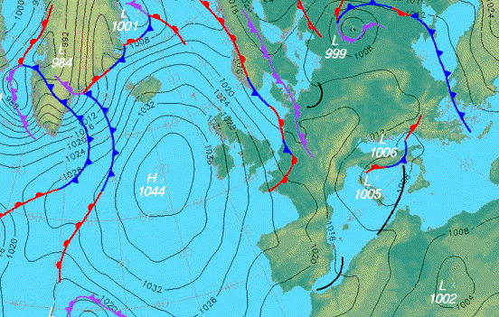

**Weather key phrases**

1. Area of high pressure
2. Area of low pressure
3. Fine weather
4. Windy conditions
5. Clear skies
6. Cloudy
7. Rainfall likely
8. Isobars (places of equal pressure)
9. Tightly packed isobars (windy)
10. Fronts (2 different masses of air)
11. Cold front
12. Warm front
13. Occluded front

1

Lesson 6: Read the information below and answer the questions on the next page.

[**As Britain prepares for the arrival of Storm Imogen in the south west**](http://www.telegraph.co.uk/news/weather/12144940/UK-Weather-Storm-Imogen-brings-ferocious-winds-and-torrential-rain.html), we examine why major storms in Britain are given names and how these names are decided.

Why do storms need names?

There is nothing British people enjoy more than talking about the weather and in 2015, they were given the chance to develop an even closer relationship by naming major weather systems affecting the UK and Ireland. In September, [**the Met Office invited members of the public to submit names for storms**](http://www.telegraph.co.uk/news/weather/11942112/Brace-yourself-for-Storm-Steve-Met-Office-reveals-typically-British-names-for-storms-after-public-appeal.html) for autumn/winter 2015/16 by social media. The idea behind the pilot project was to help raise awareness of severe weather before it strikes and to ensure greater safety of the public.

Attaching a name to a weather event has been found to help people track its progress, to allow people to prepare for and avoid danger and to make it easier to reference on social media.

Storms are given names when they are deemed to have the potential to cause 'medium' or 'high' wind impacts on the UK and/or Ireland, according to the Met Office.

Don't we already give names to storms?

Before the new system was introduced, naming was random, with the same storm sometimes being referred to by several different names. The **St Jude's Storm of October 2013**, which led to the deaths of four people, was so-called because it was due to arrive on St Jude's Day.

In Britain, we also hear about several ex-hurricanes that arrive at our shores from across the Atlantic.

Since 1953, Atlantic tropical storms have been named from lists originated by the National Hurricane Center. These lists are maintained and updated every year by the international committee of the World Meteorological Organization. There are six lists that are used in rotation.

As with the US system, the new naming system in Britain runs through the alphabet with alternate male and female names. There are no storms that begin with the less common letters Q, U, X, Y or Z.

The only time that there is a change in the list is if a storm is particularly deadly or costly, such as **Hurricane Katrina, which claimed nearly 2,000 lives in the United States and caused more than £65 billion in damage**.

If a storm is the remnants of a tropical storm or hurricane that has moved across the Atlantic, the already established method of referring to it as, for example "Ex-hurricane X", will continue.

What names have we chosen?

The winning names in full are Abigail, Barney, Clodagh, Desmond, Eva, Frank, Gertrude, Henry, Imogen, Jake, Katie, Lawrence, Mary, Nigel, Orla, Phil, Rhonda, Steve, Tegan, Vernon, Wendy.

[**Gertrude was the first named storm of 2016**](http://www.telegraph.co.uk/news/weather/12128848/Storm-Gertrude-hits-Britain-as-90mph-winds-fell-trees-and-knock-out-power-lines.html), bringing rain and strong winds to parts of Scotland and northern England. A gust of 132mph was recorded at the top of Cairngorm, as the storm caused power cuts and travel disruption.

Thousands of homes in Scotland were left without power at the beginning of February, as [**Storm Henry battered the country with 90mph winds**](http://www.telegraph.co.uk/news/weather/12135311/UK-weather-Drivers-warned-off-roads-as-Storm-Henry-lashes-Britain.html).

Gusts of 84mph forced the closure of the Forth Road Bridge and several schools in Scotland were closed.

What is next?

After Storm Imogen, the next named storm will be Jake and the list continues throughout winter 2015/16.

You MUST write in full sentences.

Why are we starting to name storms?

What was the name of the first storm of 2016 in the UK?

How did Storm Henry impact the UK?

How do names of storms get discontinued?

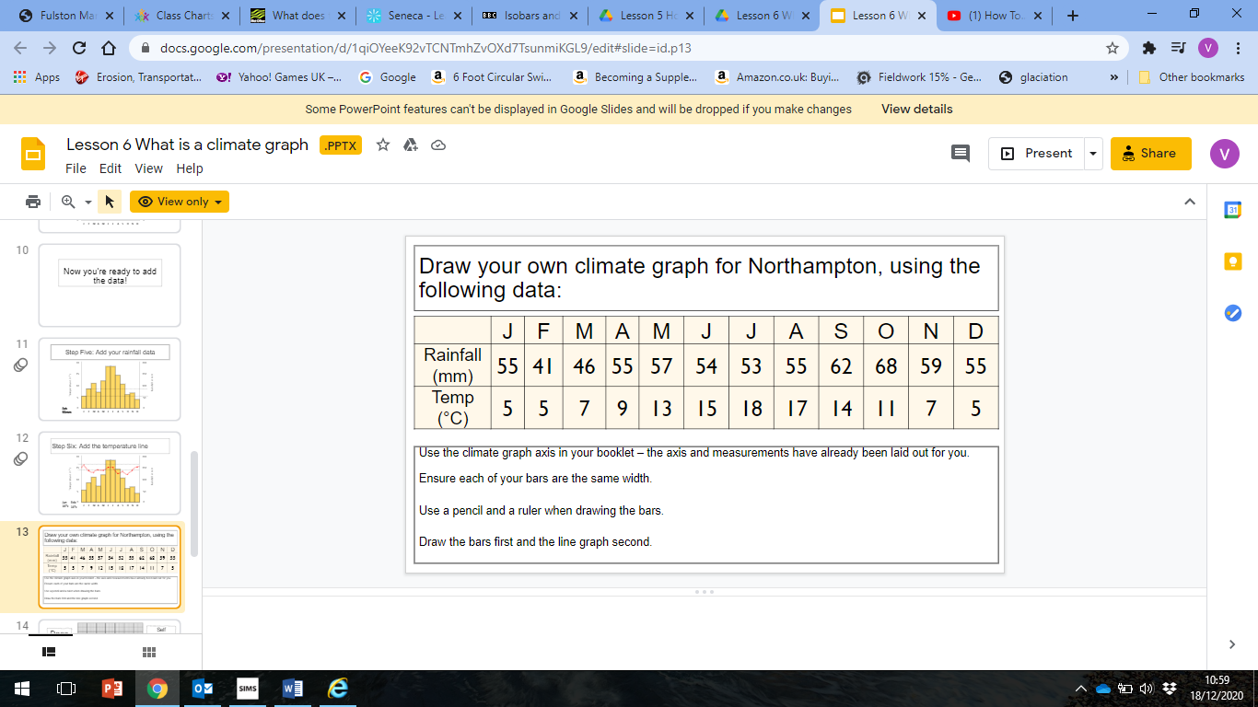Watch [this video](https://www.youtube.com/watch?v=Wv6yHl0LpgM) about climate graphs and review what you should know by reading [this detail](https://www.bbc.co.uk/bitesize/guides/z9y2k7h/revision/4) from the BBC.

Complete the climate graph for Northampton using the data on the previous page.

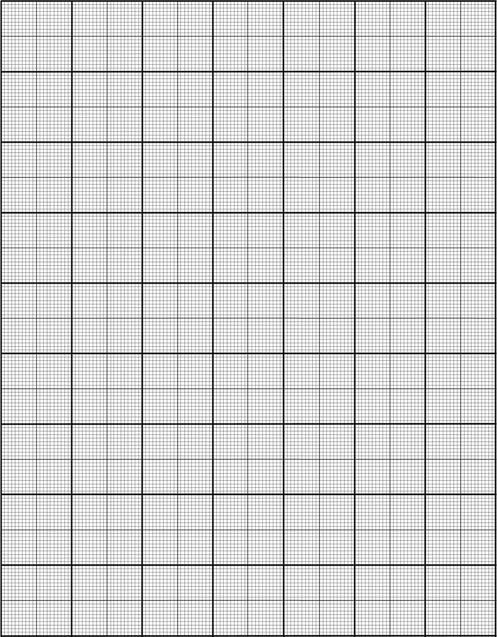

**20**

**60**

**Temperature (°C)**

**20**

**16**

**12**

**14**

**10**

**8**

**0**

**2**

**4**

**6**

**24**

**22**

**18**

**100**

**Rainfall (mm)**

**0**

**40**

**80**

**J F M A M J J A S O N D**

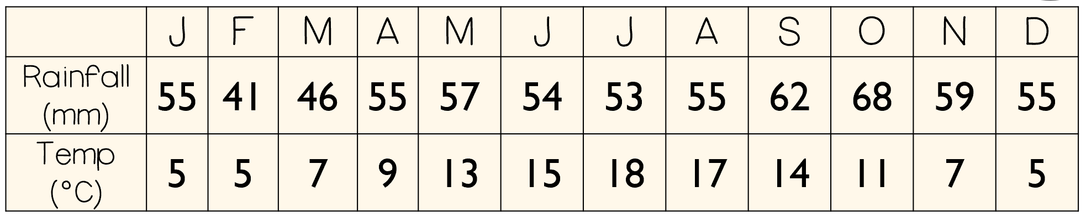

Lesson 7: Around the image below – annotate (label) around to say what the key word should be.

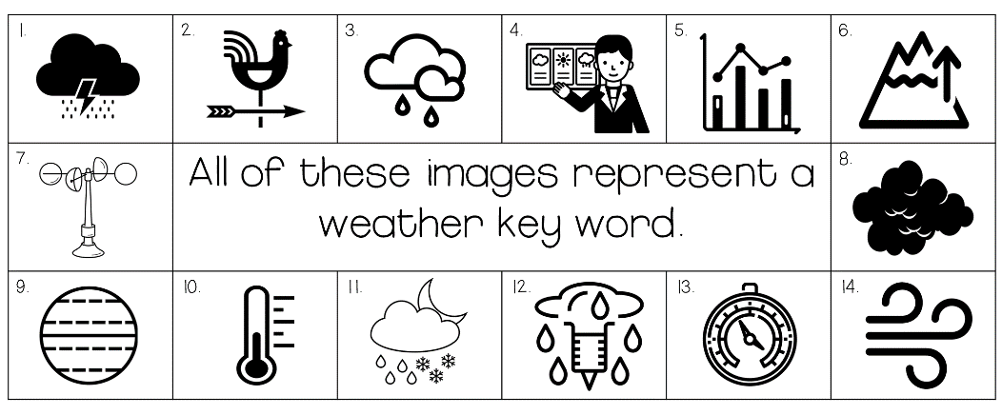

|  |  |
| --- | --- |
| Location | Temperature |
| Moscow, Russia | -20°C |
| Berlin, Germany | -12°C |
| Brussels, Belgium | -9°C |
| Amsterdam, The Netherlands | -7°C |
| London, UK | -7°C |
| Rome, Italy | -6°C |
| Naples, Italy | -2°C |
| Nice, France | -1°C |
| Barcelona, Spain | 0°C |
| Paris, France | -8°C |
| Istanbul, Turkey | 2°C |

Watch the video clip and answer the questions. <https://www.bbc.co.uk/news/world-europe-43218229>

|  |  |
| --- | --- |
| Where were the chilled winds from? |  |
| When was the last time that Rome saw snow? |  |
| What happened to the bike at Lake Constance, Switzerland? |  |
| What was the temperature in Munich? |  |
| What was happening in Bosnia? |  |

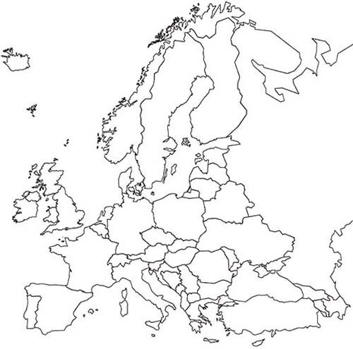

Lesson 8: The ‘Beast from the East’: First watch [this video](https://www.youtube.com/watch?v=nIKLdDWFKnA) about the Beast from the East.

|  |  |  |
| --- | --- | --- |
| Thousands of schools across the country were closed for more than one day. | 10 deaths linked to the cold and snow including a 52-year-old homeless man who was found freezing in his tent. | Cold air was swept across Europe from Siberia. |
| Met office issues a red weather warning to prevent unnecessary travel. | Some rural areas experienced lows of-12°C. | Wind speeds exceeding 70mph, higher wind speeds were mostly in coastal regions. |
| Flights and train services were delayed or cancelled. | The British Red Cross gave out blankets to people at Glasgow Airport who were stranded. | The cold air from Europe picked up moisture from the North Sea, which then fell as snow. |
| Hundreds of people stranded across the UK as roads became impassable. Many chose to leave their cars. | Snow plough, gritters and tractors used to try and clear the roads | Snow drifts in excess of 7m in places |
| Armed forces deployed to rescue stranded drivers and to transport NHS workers. | NHS cancelled non urgent operations. | 10 to 20cm fell in three days. The heaviest snow fell in southern England and the North Midlands. |

Task: Read the statements on your worksheet. Decide whether they are a CAUSE, EFFECT or RESPONSE. Use a different colour for each.

Response

Effect

Cause

Effects of ‘The Beast from the East’

1. Flights were cancelled from Heathrow Airport **135 213**

2. Hundreds of motorists were stuck on the M80 near Glasgow, many were stuck for up to 13 hours. **125 234**

3. Grimsby hospital cancelled all outpatient appointments. **137 222**

4. A baby was born on the A66 near Stockton on Tees after the parents could not make it to hospital. **132 227**

5. Flood warnings were issued by the Environment Agency for parts of Cornwall’s south coast. **125 207**

6. In Edinburgh soldiers were deployed to help transport about 200 NHS staff to and from the hospital. **128 234**

7. A man died after falling into a frozen lake in London. **136 213**

8. 49cm of snow fell at St. Athan. **127 212**

9. There were huge snowdrifts on the railway from Carlisle to Glasgow. Rail services were suspended for at least 4 days. **128 228**

10. At the Cairngorm summit there were gusts of winds over 92mph. **127 237**

11. Homes across Stafford were without power **130 218**

12. All schools in Northampton were closed, some were closed for 3 days due to the heavy snow. **135 217**

What were the effects of the ‘Beast from the East’?

Using the grid references plot the effects of the ‘Beast from the East’. When you have finished describe the distribution of the effects. Is there a pattern?

Tip: To plot a grid reference remember: ‘along the corridor and up the stairs’.

25

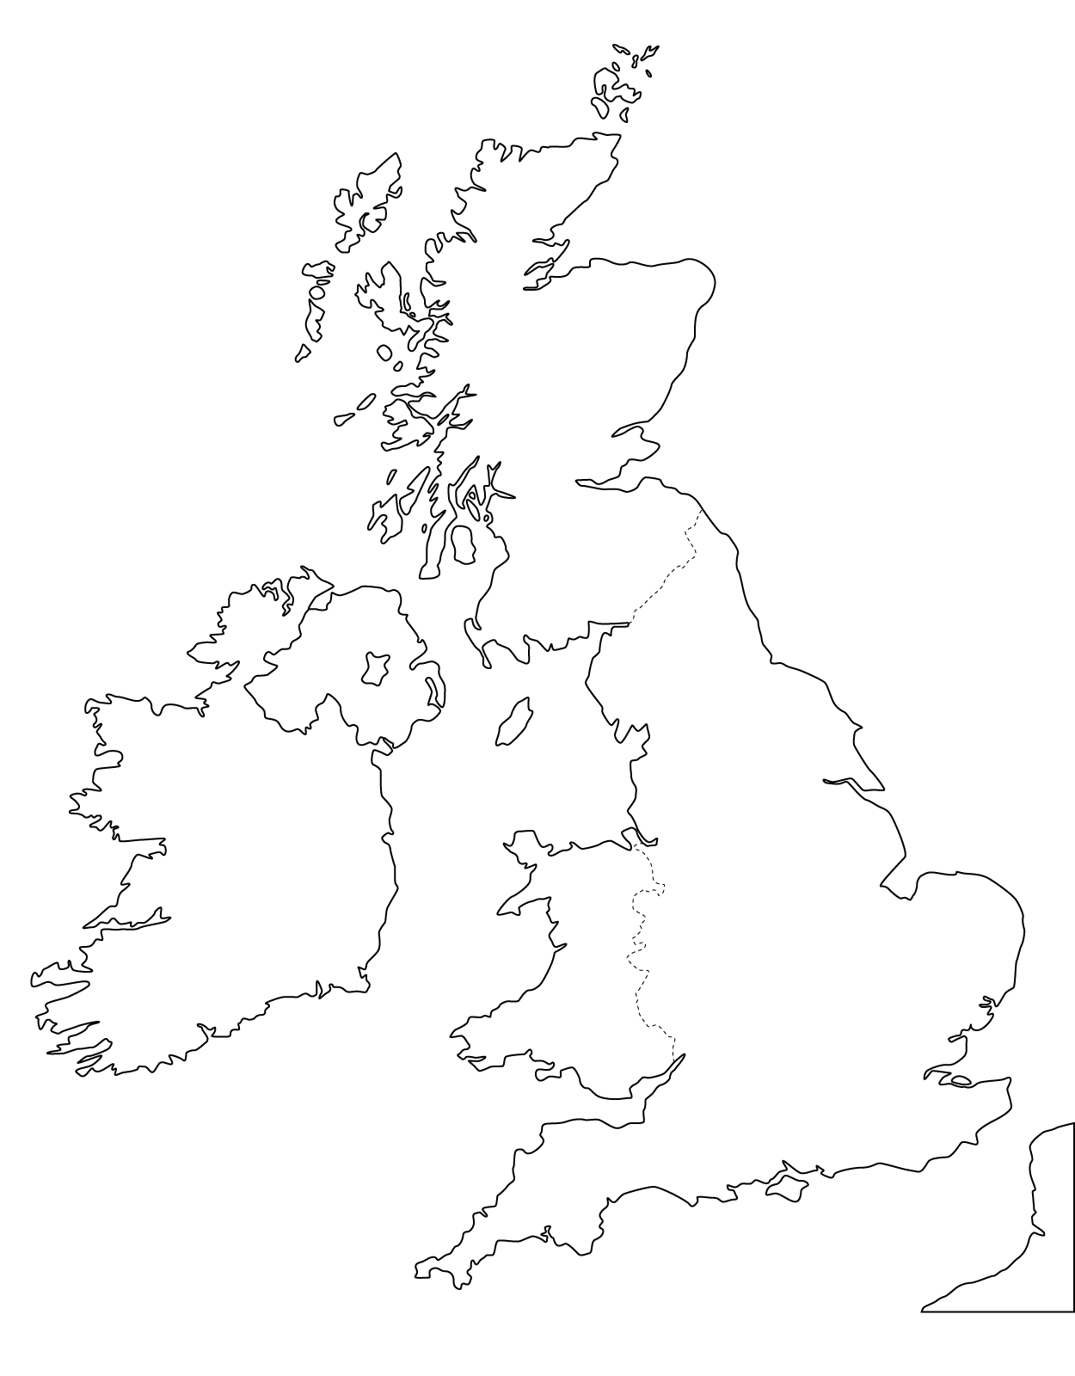

24

23

22

21

20

15

14

13

12

10

11